START HERE

Spanish and English vocabulary for AAC
Family language and communication partner practice
Plan and observe one AAC routine while learning how access, family language, and partner support affect communication.
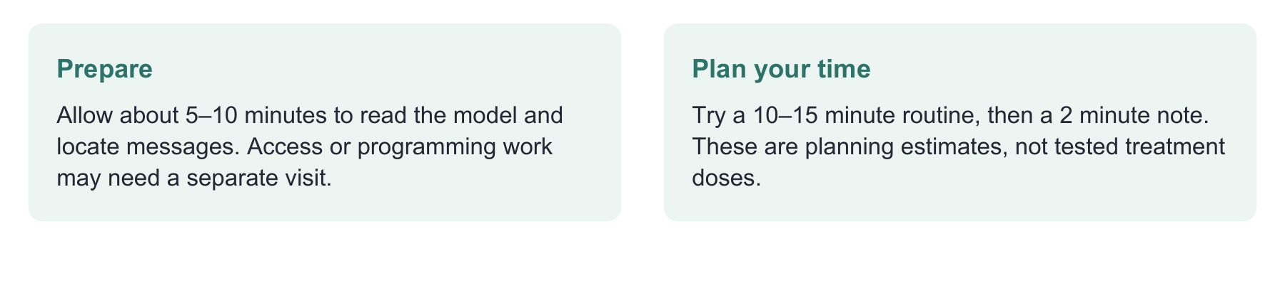
Have ready
The child’s available AAC tools, their usual access supports, a preferred activity, and the observation page.
Use one focused route
Ask the child and family what matters. Read «Model one message in a real moment». Try it, then record the support and response.
Record enough to decide
Capture one exact message, mode, language, partner support, and outcome. Agree on one next step and a review date.

Evidence behind the practice
AAC guidance supports individualized multilingual access. Reviews show variable outcomes for aided input and gaps in caregiver training research. [1–3, 15, 16]
Interpretation limit
This kit supports vocabulary and partner practice. It cannot establish access method, select a system, or replace a comprehensive AAC evaluation.

02 NOTICE THE ROUTINE

Start with a moment worth communicating
Choose an activity the child enjoys, a familiar partner, and a message that matters to the child.
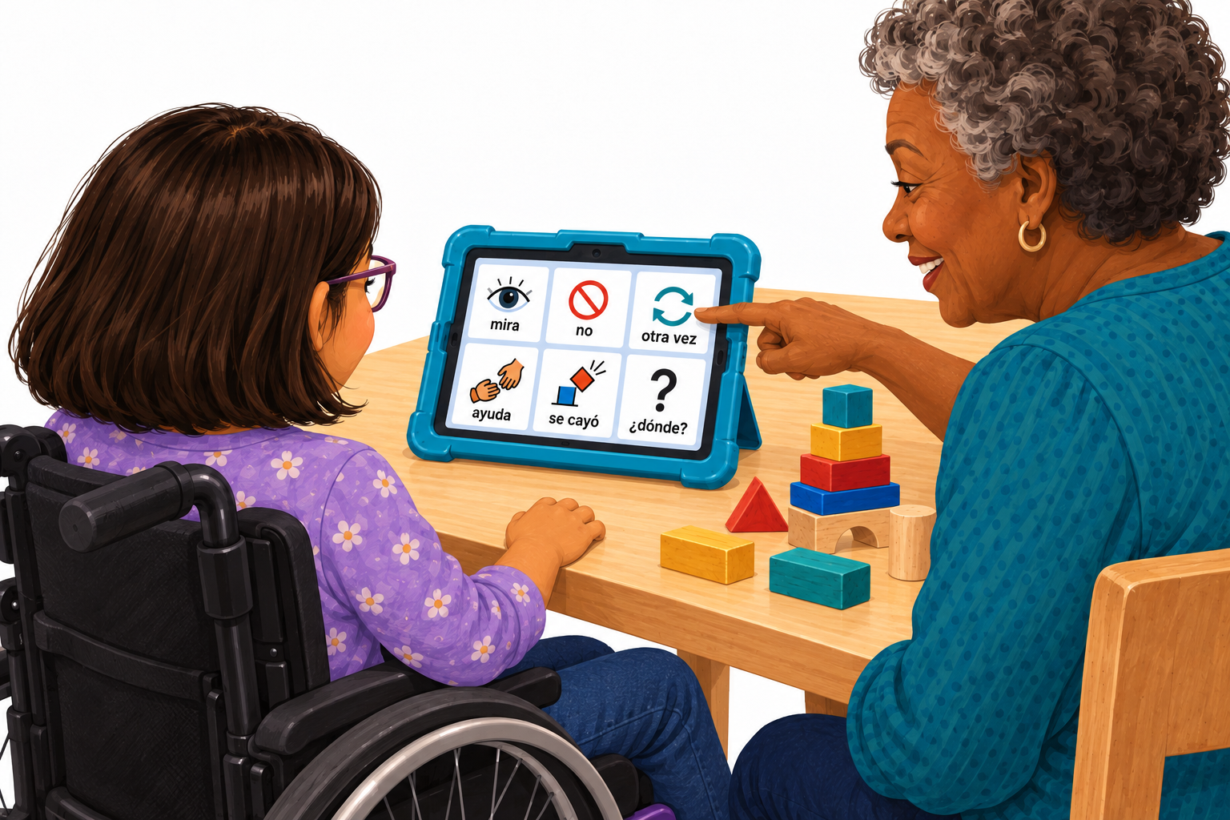
Maya and her abuela share block play with AAC available within reach. The display is illustrative, not a complete or prescribed vocabulary.
FICTIONAL CASE

Maya wants the game to continue
Maya, 8, uses speech, gestures, and an AAC system. Her abuela uses Spanish; school partners use English and Spanish.
A block tower falls during play. Abuela says, “¡Se cayó!”. Maya smiles and reaches for a block. The SLP checks Maya’s interests with her and her family, then considers “otra vez”, “mira”, and “no”, alongside names and favorite toys.
Clinical move: The next pages turn one routine into a vocabulary conversation, a modeling plan, and an observation record.
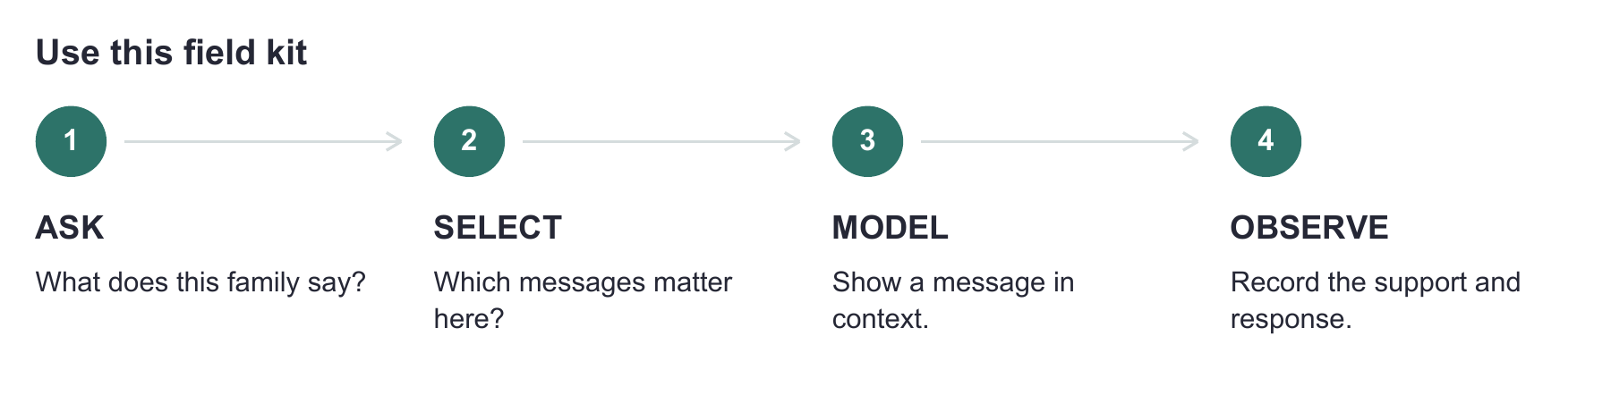
Plan for the languages and relationships in the child’s life. [1, 2] Begin with existing communication and add useful options. This planning aid is not a complete AAC evaluation or a validated vocabulary set.

03 CONVERSACIÓN CON LA FAMILIA

Las palabras de nuestra familia
La comunicación aumentativa y alternativa (CAA) incluye gestos, señas, imágenes y dispositivos que ayudan a comunicarse. Queremos elegir palabras con ustedes y escuchar lo que el niño o la niña quiere expresar.
Profesional: “Piensen en algo que les guste hacer juntos. ¿Cómo se comunican mientras lo hacen? ¿Qué más les gustaría poder decirse?”.
Abuela · ejemplo ficticio: “Armamos torres con bloques. Yo digo ‘otra vez’ y ‘se cayó’. También quiero que Maya pueda decirme cuándo quiere parar”.
Nuestro momento: qué hacemos y con quién
________________________________________________________________________________
________________________________________________________________________________
Los idiomas y las palabras que usamos en ese momento
________________________________________________________________________________
________________________________________________________________________________
Lo que nos comunica, cómo lo hace y qué nos ayuda a entenderlo
________________________________________________________________________________
________________________________________________________________________________
Nombres, apodos o palabras que queremos agregar
________________________________________________________________________________
________________________________________________________________________________

COMPRUEBEN SI LES SIRVE
“¿Así le dicen en casa? ¿Usan otra palabra? ¿Se entiende bien cuando la dice el dispositivo?”. Incluyan la preferencia del niño o la niña. Sus palabras cuentan aunque no aparezcan en esta guía.
Para el profesional: anote las palabras de la familia. Compruebe qué significan, cómo se representan y cómo suenan. Revise que el niño o la niña pueda seleccionarlas con su forma habitual de acceso. [1–3]

04 SELECT MESSAGES

Combine flexible words with personal words
Select for what the child may want to communicate, including more than requests.
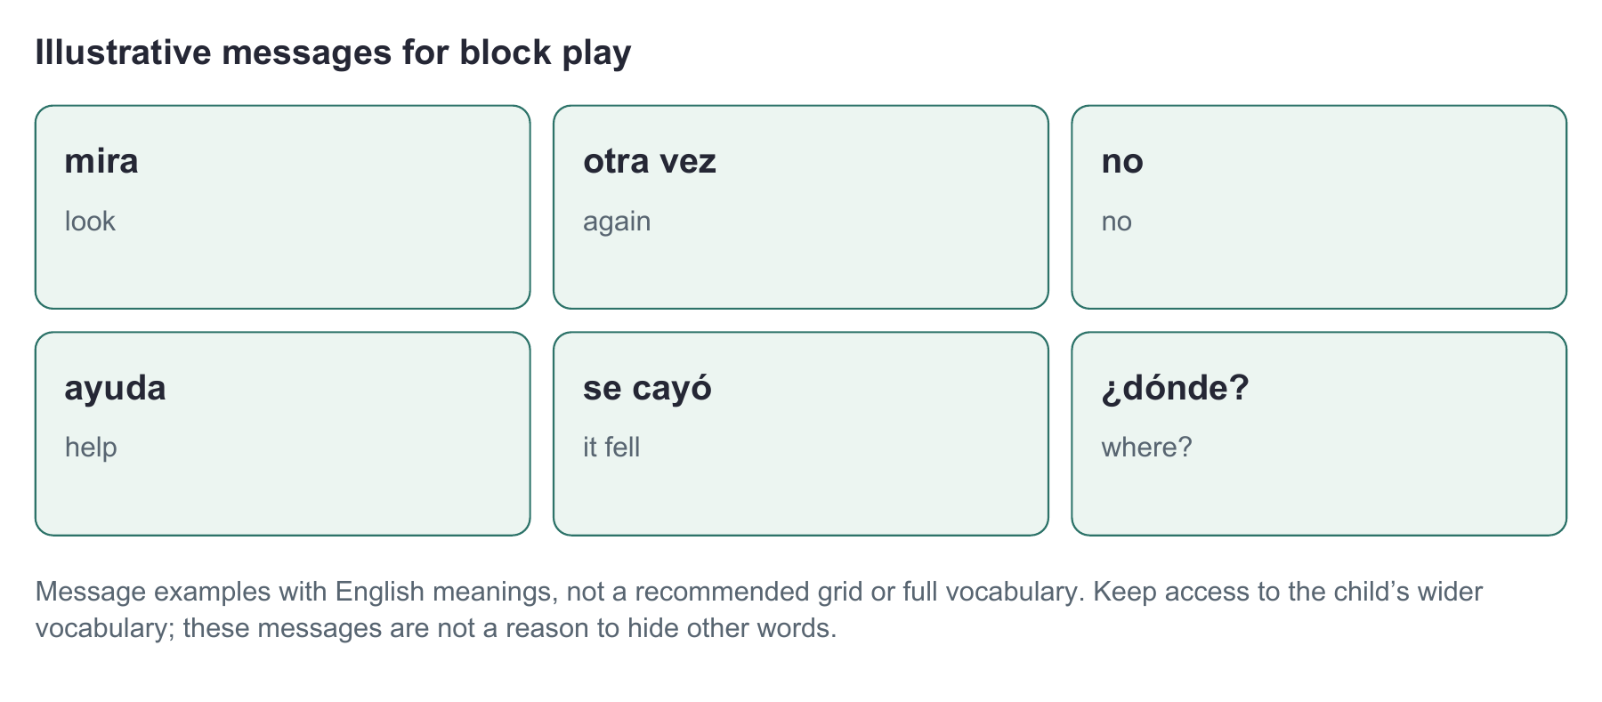
Routine | Flexible messages to discuss | Personal words to add
Block play | mira · no · otra vez · ayuda | abuela · bloques · [favorite toy]
Snack | quiero · no quiero · más · terminé | [preferred food] · [family’s word for straw]
Class project | ¿dónde? · diferente · no entiendo | [classmate] · [current project words]

MAKE SPANISH WORK AS SPANISH
Try Spanish forms in context: “quiero”, “ella quiere”, “mi pelota”, “las pelotas”. Check labels, grammatical options, and speech output. Do not copy English word order or rely only on infinitives. These examples are not milestones or required targets. [4]
Our messages + the personal words we will add
________________________________________________________________________________
________________________________________________________________________________
Include words for relationships, interests, actions, descriptions, and questions. [1, 4] These examples are a starting point for discussion, not a teaching sequence or required vocabulary size.

05 TRY IT TOGETHER

Model one message in a real moment
Aided language modeling pairs speech with selections on AAC. [1] Modeling is one teaching component; observe the response and adapt the plan. [15]
1. Set up for access Position the system for Maya’s established access. Check that Maya and abuela can find the messages. Keep familiar word locations; plan changes with the team. Have a usable backup for device downtime.
2. Join the play The tower falls during play. Abuela says “¡Se cayó!” and models an available matching message. Maya reaches for a block. Abuela says “Otra vez” while selecting that message.
3. Leave room for a response Pause for Maya’s response, allowing the time her access method requires. Watch for gesture, gaze, speech, or AAC. She does not have to copy the model to continue playing.
4. Respond to the meaning Maya selects “otra vez”. Abuela responds “¡Otra vez!” and they build again. Record that the selection followed an immediate model.
5. Honor a different message Later Maya says or selects “no”. Abuela stops and acknowledges it. If Maya turns away or uses another mode, check its meaning with her. Refusal is communication too. [3]

IF THERE IS NO SELECTION
Check interest, message availability, access, and partner understanding. A missing selection in one moment does not establish lack of ability or readiness. Continue responding to other effective modes; do not require a device selection to earn the next turn. [3]
My routine · message to model · exact words I will say
________________________________________________________________________________
________________________________________________________________________________
Partner rehearsal: the SLP demonstrates, abuela tries, and they discuss what felt easy or difficult. Observe the partner as well as the child. This is an original coaching example, not a tested protocol. [16]

06 REGIONAL OPTIONS

Check the word with this family
Use these documented options to start a conversation with families from Puerto Rican, Cuban, Mexican, Dominican, and Venezuelan communities.
Meaning | Word | Dictionary locations within the five communities covered here
Drinking straw | sorbeto [5] | Puerto Rico
Drinking straw | calimete [6] | Dominican Republic
Drinking straw | popote [7] | Mexico; Dominican Republic
Drinking straw | pitillo [8] | Cuba; Venezuela
Banana | guineo [9] | Mexico; eastern Cuba; Dominican Republic; Puerto Rico; western Venezuela
Banana | cambur [10] | Venezuela
Sweet orange | china [11] | Dominican Republic; Puerto Rico
Small kite | chiringa [12] | Cuba; Dominican Republic; Puerto Rico
Kite | papalote [13] | Mexico; Cuba; Dominican Republic
Kite | papagayo [14] | Southeastern Mexico; Venezuela

Ask: “¿Cómo le dicen a esto en casa? ¿Usan otra palabra? ¿Cuál quieren que aparezca en el dispositivo?”.
Family · fictional example: “En casa decimos popote. En la escuela usa straw. Queremos que tenga las dos”.

SAME SPELLING CAN MEAN SOMETHING ELSE
ASALE records sorbeto as a drinking straw in Puerto Rico and a wafer in Cuba. Check the object and meaning; a nationality label cannot make the choice. [5]
Family’s word · intended meaning · output checked
________________________________________________________________________________
These dictionary entries document meanings, not frequency among children or every family’s preference. A child may use more than one variety. Confirm the object, word, and desired output with the child and family. This is a starting list, not five complete dialect dictionaries.

07 OBSERVE AND ADJUST

Record the support behind the message
Write the message, the opportunity, the partner’s support, and what happened next. Use this descriptive record across real routines.
Moment | Child’s communication | Support and result
Block play · fictional | Selected “otra vez” | Immediately after partner modeled it. They built again. Use after model.
Snack · fictional | Selected “no” | Adult asked “¿Quieres más?”; no model or pointing cue. Snack stopped. Response to a question.
Later play · fictional | Selected “mira” | No immediate model, directive, or pointing cue observed. Partner looked. Record exact context.

DISTINGUISH THE CONDITIONS
“After a model”, “after a question”, and “without an immediate cue” describe different conditions. Earlier teaching may still have occurred. These labels are documentation aids, not a standardized scoring system.
☐ The message was available and the child could access it.
☐ The label, symbol, and voice conveyed the intended meaning.
☐ We recorded gestures, speech, gaze, and other effective modes too.
☐ We checked the likely meaning and recorded how the listener responded.
Next step · partner practice needed · who will help · review date
________________________________________________________________________________
________________________________________________________________________________
If use remains limited, revisit access, vocabulary, partner practice, and real opportunities together. [1–3, 15, 16] Record whether the next routine becomes easier or more useful. Do not remove a language because one routine produced little use.

CLINICAL REFERENCES AND LIMITS

What the evidence supports
Useful practice combines research, clinical judgment, and the child’s and family’s priorities. The original activities in this kit have not been clinically validated.
Evidence | What it means for this kit
Augmented input review [15] | Response varied; input alone was not consistently effective. Monitor outcomes and adjust support rather than assuming modeling is enough.
Caregiver review [16] | Caregiver training and outcomes were incompletely reported, with limited representation of marginalized families. Observe the partner’s practice and ask what is feasible.
Spanish vocabulary analysis [4] | Informs early vocabulary and grammar. Does not validate one word list for every child, age, or Spanish variety.

[1] American Speech-Language-Hearing Association. Augmentative and alternative communication (AAC). Practice Portal. https://www.asha.org/practice-portal/professional-issues/augmentative-and-alternative-communication/
[2] Soto, G., & Yu, B. (2014). Considerations for the provision of services to bilingual children who use augmentative and alternative communication. AAC, 30(1), 83–92. https://doi.org/10.3109/07434618.2013.878751
[3] National Joint Committee for the Communication Needs of Persons With Severe Disabilities. AAC; Communication Bill of Rights (3rd ed.). https://www.asha.org/NJC/AAC/ • https://www.asha.org/NJC/Communication-Bill-of-Rights/
[4] Soto, G., & Cooper, B. (2021). An early Spanish vocabulary for children who use AAC: Developmental and linguistic considerations. AAC, 37(1), 64–74. https://doi.org/10.1080/07434618.2021.1881822
[15] Chazin, K. T., Ledford, J. R., & Pak, N. S. (2021). A systematic review of augmented input interventions and exploratory analysis of moderators. American Journal of Speech-Language Pathology, 30(3), 1210–1223. https://doi.org/10.1044/2020_AJSLP-20-00102
[16] Elmquist, M., Crowe, B., Wattanawongwan, S., Reichle, J., Pierson, L., Simacek, J., Hong, E. R., Liao, C.-Y., & Ganz, J. B. (2025; online 2023). Caregiver-implemented AAC interventions for children with intellectual or developmental disabilities: A systematic review. Review Journal of Autism and Developmental Disorders, 12, 290–310. https://doi.org/10.1007/s40489-023-00394-2
Clinical guidance [1–3] is distinguished from research synthesis [15, 16] and vocabulary analysis [4]. Sources checked September 26, 2026.

DICTIONARY REFERENCES AND COMMUNITY REVIEW

Check each regional meaning
A dictionary entry is a starting point. The child’s and family’s actual language is the final check for this vocabulary choice.
Asociación de Academias de la Lengua Española (ASALE). (2010). Diccionario de americanismos. Entries checked September 26, 2026. Meanings and geographic qualifiers were reviewed together.
[5] ASALE. Sorbeto, II.1 (Puerto Rico); sorbete, I.1. https://www.asale.org/damer/sorbeto • https://www.asale.org/damer/sorbete
[6] ASALE. Calimete, I.1. https://www.asale.org/damer/calimete
[7] ASALE. Popote, I.1. https://www.asale.org/damer/popote
[8] ASALE. Pitillo, I.1. https://www.asale.org/damer/pitillo
[9] ASALE. Guineo, I.1; eastern Cuba and western Venezuela qualifications. https://www.asale.org/damer/guineo
[10] ASALE. Cambur, I.1. https://www.asale.org/damer/cambur
[11] ASALE. China, IV.2. https://www.asale.org/damer/china
[12] ASALE. Chiringa, I.1 (small kite). https://www.asale.org/damer/chiringa
[13] ASALE. Papalote, I.1. https://www.asale.org/damer/papalote
[14] ASALE. Papagayo, I.1; southeastern Mexico qualification. https://www.asale.org/damer/papagayo

BEFORE SHARING A WORD SET
Ask speakers from the intended community to try the actual labels, symbols, and voice output. Invite corrections. Do not present this table as a national vocabulary rule or a complete AAC language system.
Editorial review is not community validation. Independent review by AAC users and families across the five communities has not yet occurred. Family confirmation, access assessment, and trial use remain essential.

