START HERE

Planning a Spanish and English evaluation
A practical route from referral to follow up
Leave planning with one answerable question, an accessible task, and a follow-up decision.
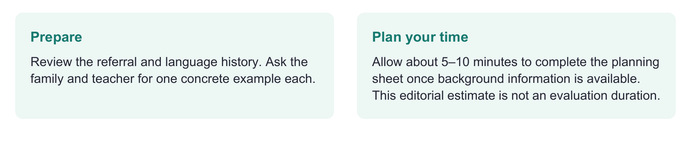
Have ready
Referral, language and schooling history, family priority, access information, and the planning sheet.
Use one focused route
Choose the closest case → plan one observation → identify what would change the next step. Read the other cases later.
Record enough to decide
Task, languages and communication modes, supports, exact concern, missing evidence, and who will obtain it by when.

Evidence behind the practice
ASHA provides professional guidance; IDEA establishes US school evaluation requirements. This decision map is an original synthesis, not a validated algorithm. [1–3, 7]
Interpretation limit
Begin needed language and access supports while completing a timely evaluation. Do not postpone evaluation simply to wait for more English exposure.

02 START HERE

Make the next session answer a question
Write the communication problem as an activity: “Explain a playground disagreement,” rather than “Obtain a language score.”
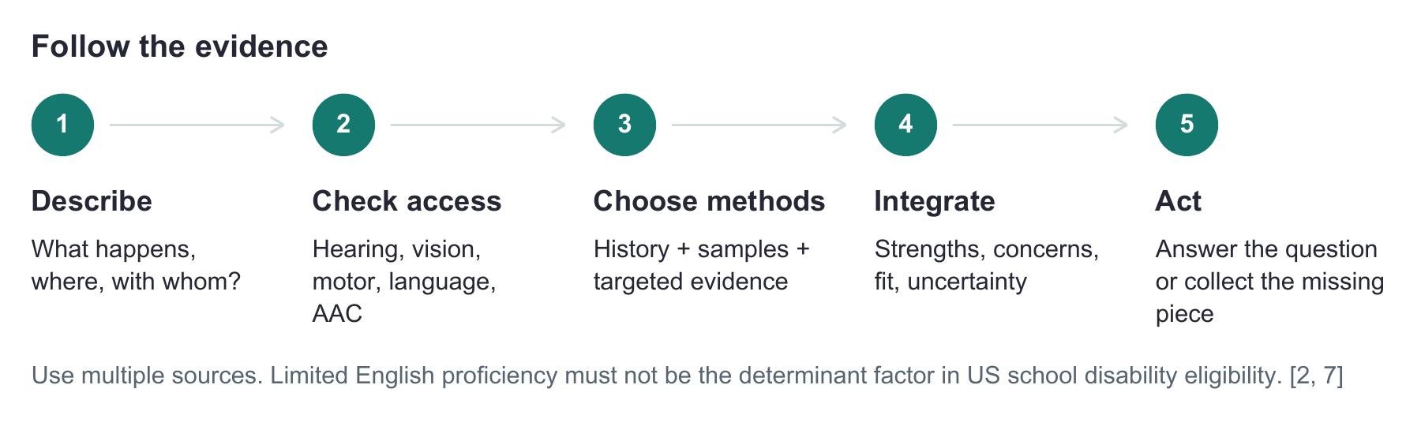
Ask the caregiver: ¿Cuándo se le hace fácil comunicarse? Cuénteme qué pasó la última vez que necesitó ayuda para expresarse.
Get an example, not only a concern label.
Ask the teacher: What was the task, what did the child communicate, and what changed after support?
Separate task demands from assumptions about ability.
Concern | Useful starting evidence
Speech clarity | Single words + connected speech in used languages; family intelligibility examples
Words or grammar | History + language samples + language-specific probes
Learning | Accessible baseline + recorded teaching + retest/transfer
Little speech or AAC | Communication functions + access + supported observation

Before selecting a score
Check the child’s age, languages and varieties, experience, schooling, access and the tool’s intended use. Arrange linguistic expertise when needed. [1, 3]

03 FICTIONAL TRAINING CASES

Two children two different plans
Similar referrals can require very different methods.

Case A Sofía age 5
Spanish is the primary home language. English became part of daily schooling this year. The teacher reports difficulty following English classroom explanations. The family describes successful Spanish play and conversation.
Clinician: Cuando juegan en casa, ¿cómo le va cuando usted le pide que haga algo? ¿Qué hace si no entiende?
Ask for familiar-context examples.
Plan: Observe a familiar task in Spanish, sample both languages as feasible, and document English instruction and opportunities.
A Spanish tool is a candidate only after checking its population and scoring rules.
Interpretation move: Check the same communication need in familiar Spanish contexts and examine what instruction makes accessible. Family strengths are evidence to investigate, not proof that no disorder is present. Support English learning while completing the evaluation. [1, 2]

Case B Daniel age 5
Daniel’s family identifies as Latino. He uses English throughout the day and understands a few Spanish routines. His family and teacher report difficulty explaining events in English.
Clinician: Which language lets Daniel tell you the most? Give me a recent example.
Identity does not establish language proficiency.
Plan: Prioritize accessible English assessment and family history; document the specific Spanish experience.
PLS 5 Spanish is not intended for primarily English-speaking children with little Spanish. [4]

Same clinical habit in both cases
Choose the interpretation supported by the child’s actual experience. Do not use a language-exposure percentage as a diagnostic cutoff.

04 FICTIONAL TRAINING CASE

When access changes what you can observe
Case C: Valeria, age 8, uses Spanish with family, English at school and AAC in both settings. A referral says she “cannot make sentences.”
Clinician to team: Show me the message Valeria wanted to communicate. Were the needed words available, and could she reach them?
Separate an observed output from a claim about language.
Clinician to family: ¿Qué le gustaría a Valeria poder decir con su sistema de comunicación? ¿Cómo se lo hace saber ahora?
Identify messages that matter at home.
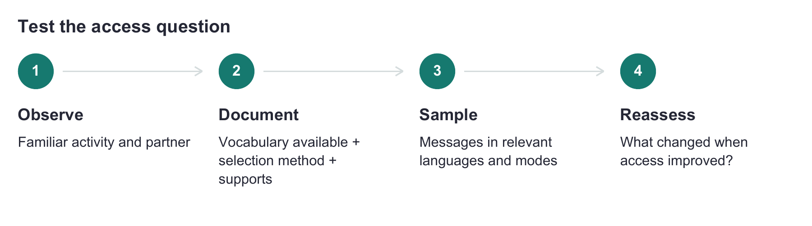
Next move: Collaborate with AAC expertise. Collect language evidence that does not require more speech or motor output than Valeria can access. Improvement after an access change informs the next question; it does not independently establish or exclude a language disorder. [1]

Brief the interpreter before the visit
Before | During | After
Explain the task, exact prompts and what to preserve | Record prompts, language changes and child responses | Review ambiguous words, dialect, support and interpretation limits

Say this in your report
“Responses were collected using [languages/modes]. [Access support] allowed [observable change]. This supports [limited conclusion]. We still need [specific evidence].” Use only wording that matches the session. [3]

05 COPY AND COMPLETE

Your next session on one page
Plan one real task and record the support and evidence needed next.
Child code / age / grade / languages and varieties / date
________________________________________________________________________________
Real communication task | Current strength | Breakdown to investigate

Family example and priority
________________________________________________________________________________
School example and language of instruction
________________________________________________________________________________
Access supports / interpreter or bilingual collaborator / role
________________________________________________________________________________
Method | Question it answers | Language and support | What would change the next step
Family/teacher information
Sample or observation
Targeted probe or learning task
Formal tool if appropriate

Evidence that converges / evidence that conflicts
________________________________________________________________________________
What is supported now / what is still uncertain
________________________________________________________________________________
Action / person responsible / date to revisit
________________________________________________________________________________

Close the loop
Adjust blocked access and observe again. Sample both contexts when reports conflict. Persistent concerns need broader evaluation. One score or learning response cannot decide the case. [1, 2, 6]

06 SOURCE NOTES

Sources behind the decision map
This is an original planning aid. The fictional cases demonstrate reasoning, not diagnostic outcomes.
[1] American Speech-Language-Hearing Association. (n.d.). Multilingual service delivery in audiology and speech-language pathology. Practice Portal. https://www.asha.org/practice-portal/professional-issues/multilingual-service-delivery/
[2] U.S. Department of Education. (n.d.). IDEA regulations, 34 CFR §300.304, evaluation procedures. https://sites.ed.gov/idea/regs/b/d/300.304
[3] American Speech-Language-Hearing Association. (n.d.). Collaborating with interpreters, transliterators, and translators. Practice Portal. https://www.asha.org/practice-portal/professional-issues/collaborating-with-interpreters/
[4] Pearson. (n.d.). Screen or assess emerging communication skills in English or Spanish with the PLS 5 family. Publisher brochure. https://www.pearsonassessments.com/content/dam/school/global/clinical/us/assets/pls5/pls-5-brochure.pdf
[5] Pearson. (n.d.). Clinical Evaluation of Language Fundamentals Fourth Edition Spanish. Product information and Spanish edition comparison. https://www.pearsonassessments.com/store/en/usd/p/100000436.html
[6] Orellana, C. I., Wada, R., & Gillam, R. B. (2019). The use of dynamic assessment for the diagnosis of language disorders in bilingual children: A meta-analysis. American Journal of Speech-Language Pathology, 28, 1298–1317. https://doi.org/10.1044/2019_AJSLP-18-0202
[7] U.S. Department of Education. (n.d.). IDEA regulations, 34 CFR §300.306(b), determinant factors in eligibility. https://sites.ed.gov/idea/regs/b/d/300.306/b

Edition check
CELF 4 Spanish US and CELF 5 Spain have different normative populations. Match the edition to the interpretation. [5]
Sources checked 26 September 2026.

