START HERE

Dynamic assessment for bilingual children
Planning and documenting one teaching cycle
Observe how one communication target changes with teaching; plan the next support.
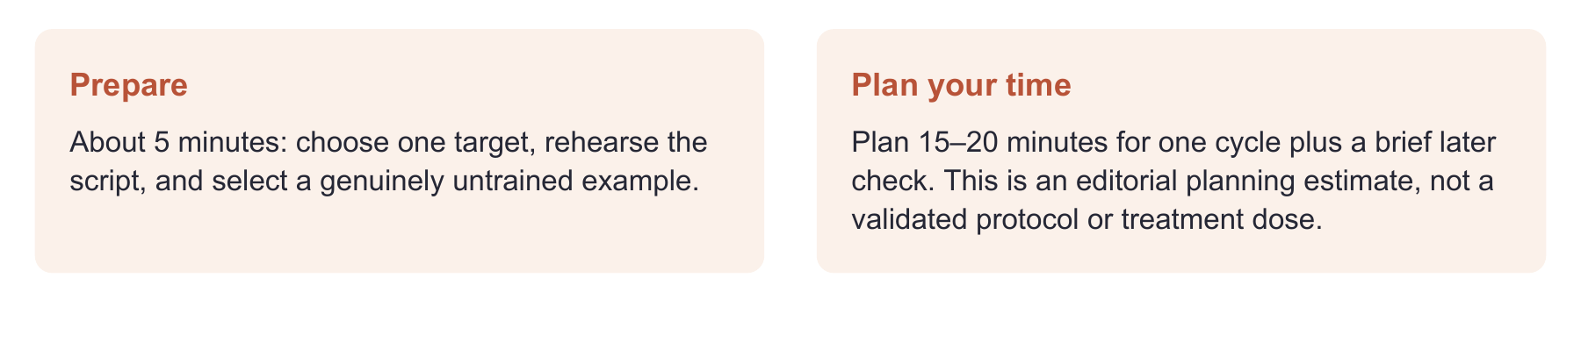
Have ready
Bridge pictures, the recording sheet, two boxes and a block for transfer, and the child’s usual access supports.
Use one focused route
Read “Start with a story” and “Make your teaching visible”; run baseline → teaching → retest → new example. Use just one mini lab if a different target fits better.
Record enough to decide
Keep the exact response, actual cue, language, access conditions, teaching time, and what happened on the untrained example.

Evidence behind the practice
Bilingual DA reviews show promise but substantial study limitations. The strongest support here concerns learning observations, not a score from this activity. [2,3]
Interpretation limit
These are original teaching probes. They do not carry published diagnostic accuracy or a pass/fail rule. Pause and adapt if the task or access is unsuitable.

02 SET UP

Start with a story the child can see
Target: retell the problem, action, and outcome after hearing a short story.
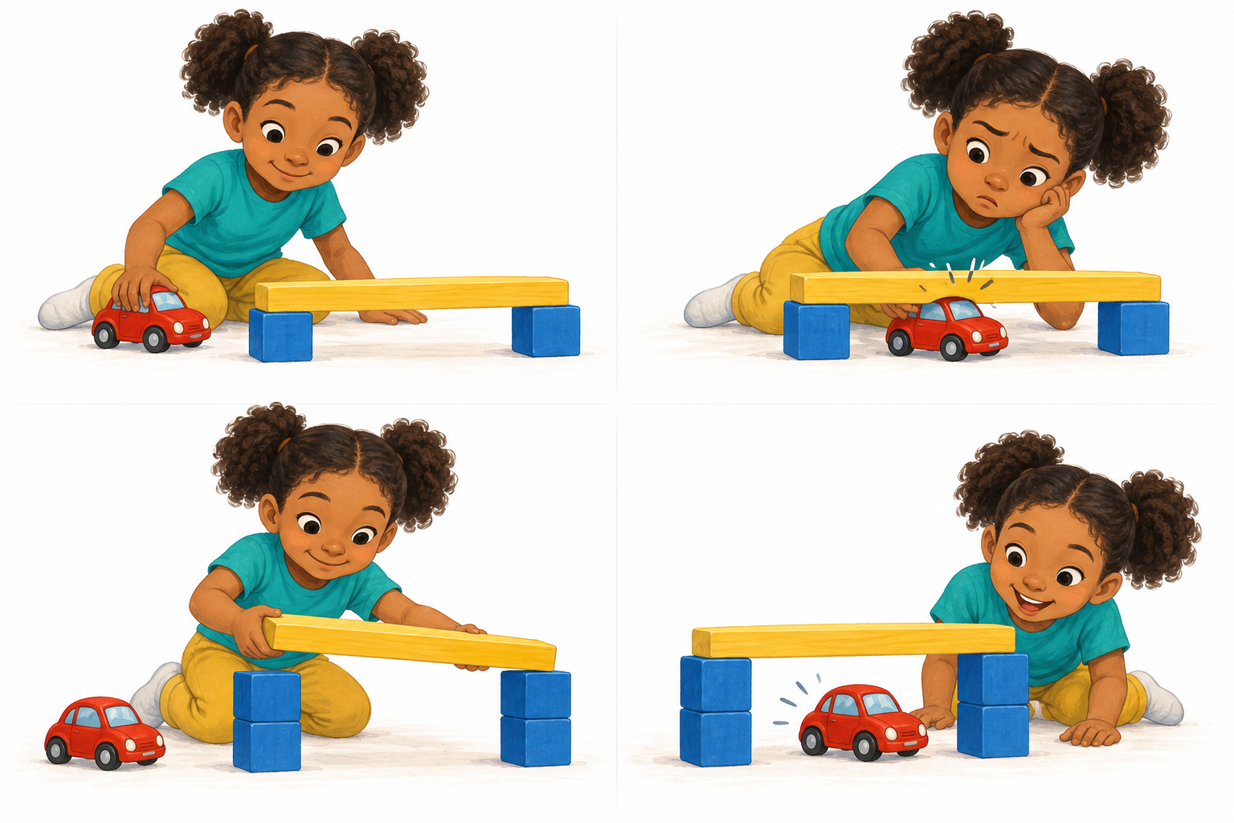
Show the four panels in order. The car goes UNDER the bridge.
Read the story once at baseline and once at retest. Use the planned language and usual access supports. This is modeled retelling, not spontaneous storytelling. All cases are fictional.
ENGLISH: “Luz built a bridge. The car could not fit underneath. Luz made the bridge higher. The car went under it. Tell me what happened so someone who was not here can understand.”
ESPAÑOL: “Luz hizo un puente. El carrito no cabía por debajo. Luz hizo el puente más alto. El carrito pasó por debajo. Cuéntame la historia. Piensa que quien te escucha no vio lo que pasó”.

BEFORE TEACHING
Collect any independent language sample before this activity and note prior exposure. Keep the pictures visible. After the invitation, allow a response without additional questions or strategy cues. Record silence or refusal descriptively.

03 MEDIATE

Make your teaching visible
Teach a way to explain the story, then observe what the child does with it.
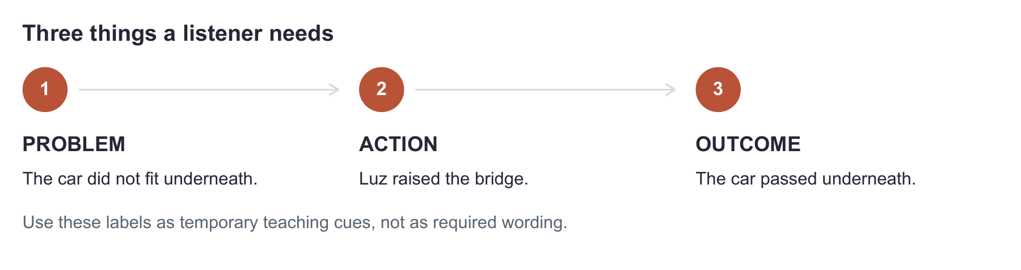
SLP: “A listener needs to know what went wrong, what Luz did, and what happened next. She made the bridge higher because the car did not fit.”
SLP EN ESPAÑOL: “Para que se entienda la historia, cuenta qué problema tuvo Luz, qué hizo para resolverlo y qué pasó al final. Hizo el puente más alto porque el carrito no cabía”.
CHILD MAY SAY: “Car. Puente.”
Acknowledge the ideas. Point to the difficulty: “¿Qué problema había?” Record that specific cue.
CHILD MAY SAY: “No cabía. She made it higher.”
The child has linked the difficulty and action across languages. Record the meanings and language forms separately.
CHILD MAY SAY: “She made it higher because it wouldn’t fit.”
Invite another attempt with less teaching help. A repeated model alone does not establish transfer.

NAME THE HELP
I = planned probe only; G = general reminder; S = specific question/cue; M = extra model/joint answer. The planned retell includes an oral story model. Keep exact cues and note if less help was needed later. These descriptive labels are not a validated scale; do not average them.
Maintain usual access supports. Record AAC, interpretation, hearing access, positioning, and response time separately from teaching cues. If a support supplies answer content, record that too. [1]

04 RETEST AND TRANSFER

Separate practice from learning evidence
First remove teaching prompts. Then change the example.
1. Retest the bridge story Remove teaching labels. Keep pictures and access supports. Read the same short story and invitation once, as at baseline. Do not add a strategy reminder. This is retelling a practiced story after an oral model.
2. Try a new problem Act out and narrate once: “Nico tried to put a block in a box. It did not fit. He found a bigger box and put it inside.” / “Nico quiso guardar un bloque en una caja, pero no cabía. Buscó una caja más grande y lo guardó ahí”. Invite a retell without extra questions.
3. Check later when feasible Probe before any new teaching. Record the exact interval and intervening activity. No interval in this kit is a diagnostic standard.
Phase | Fictional response | What it shows
Baseline | “A car and a girl.” | Names the scene; does not state the problem.
Teaching | “No cabía” after “¿Cuál era el problema?” | Problem expressed with a specific cue.
Retest | “It didn’t fit, so she made it higher. Then it went.” | Problem, action, outcome, and connection after the usual story model; no extra teaching cues.
New story | “He got a big box. The block went in.” | Action and outcome expressed; problem and causal link not explicit.

WRITE THIS
“After models and specific questions during teaching, the child linked problem, action, and outcome when retelling the practiced story after its oral model. No extra cues were given. In one untrained story, the problem and causal link remained unstated. Next, teach problem statements across varied examples.”
The stories are not calibrated for equal difficulty. This pattern informs teaching; it does not confirm or exclude disorder. Consider language history and other evaluation findings. [1–3]

05 MORPHOLOGY AND SYNTAX

Change the target and keep the learning question
Choose one form or relation that matters in the child’s communication.
MORPHOLOGY MINI LAB

Tell when an action happened
Use a familiar action picture sequence that clearly establishes yesterday and shows a completed action. Select forms appropriate to the child’s language variety.
Baseline: show the completed event and ask “¿Qué hizo ayer?” Record the answer. Teach: “Ahora está pintando. Ayer pintó un dibujo y lo terminó”. Point out the completed past event, invite a supported try, then remove the model.
Clinical move: Transfer: use a new familiar action such as jumping. Ask “¿Qué hizo ayer?” without modeling “saltó”. Record past-time meaning separately from the specific form targeted.
POSSIBLE RESPONSE: “Ayer estaba saltando.”
This is a grammatical way to describe past activity. It does not demonstrate the targeted completed-event form “saltó”. Judge whether the visual context actually called for that form.
ENGLISH OPTION: Use a separate ongoing/completed contrast: “She is jumping now. Yesterday she jumped.”
Choose an English target from the child’s profile. Spanish and English forms do not have identical learning demands.
SYNTAX MINI LAB

Give a reason
Stage a visible problem: a container will not close because the toy is too large.
Baseline: “Why won’t it close?” / “¿Por qué no cierra?” Teach how one event explains another: “It won’t close because the toy is too big” / “No cierra porque el juguete es muy grande”.
Clinical move: Transfer: a toy cannot pass through a narrow opening. Ask for the reason without a model. Record the causal meaning and the selected sentence form separately.

CLINICAL MOVE
Define the target before starting: meaning, grammatical form, or both. These original adaptations have no diagnostic accuracy estimates; evidence for a published narrative task does not validate a local grammar task. [2–4]

06 SEMANTICS AND SPEECH

Make word learning and speech observable
Use the same phases, with outcomes that match the target.
SEMANTICS MINI LAB

Learn a word and its meaning
Choose a useful word after checking the concept and both labels. If either label is known, describe the task as learning the other label or deepening meaning. Example: “frágil / fragile”.
Baseline: ask what the word means and offer a safe picture choice. Teach with a paper model and a picture of a thin ornament: “Es frágil: se rompe o se daña fácilmente” / “It is fragile: it breaks or is damaged easily”. Contrast with a sturdy rubber ball.
Clinical move: Probe meaning, picture recognition, and word retrieval separately. Later, present a new delicate object. Record whether the child recalls the word, explains the idea, or only selects the picture. [5]
SPEECH MINI LAB

Observe response to a speech cue
If the child’s assessment supports exploring Spanish /k/, choose familiar words and document the language variety. No age cutoff is supplied here.
Baseline: elicit familiar “casa” without an immediate model. Teach: “Escucha: casa. Ahora tú”. If needed, model “ca…sa”, then blend into “casa”. Record the production and whether the syllable model helped. This is supported practice. Later, elicit the whole word from its picture without a model, then an untreated familiar word such as “cama”.
Clinical move: Fictional pattern: casa → [tasa] at baseline; syllable model → [ka]; retest casa → [kasa]; untreated cama → [tama]. The practiced word changed; transfer was not shown. Next, examine additional untreated words and cue conditions.

RECORD WHAT CHANGED
For speech, retain productions and cue details. For semantics, distinguish meaning from the word form. Hearing access, vocabulary familiarity, and motor demands can change interpretation.
A stimulability activity can inform speech planning. It does not establish a disorder or diagnose childhood apraxia of speech. These local examples are not validated language or motor-speech tests. [6]

07 COPY AND USE

Take this page into the session
Write exact responses. Keep teaching help and communication access separate.
Child code • date • language varieties • communication mode
________________________________________________________________________________
One target • participation purpose • observable response (meaning, form, or both)
________________________________________________________________________________
________________________________________________________________________________
Usual access supports • baseline conditions • untrained transfer item
________________________________________________________________________________
________________________________________________________________________________
Phase | Exact response | Actual teaching cue and conditions
Baseline
Teaching 1
Teaching 2
Retest without teaching
Untrained example
Later probe • interval: ____

Teaching time and opportunities actually provided
________________________________________________________________________________
What changed • support still needed • next teaching step and later check date
________________________________________________________________________________
________________________________________________________________________________
☐ I distinguished responses after the story model from responses needing extra cues.
☐ I documented meaning separately from language-specific form.
☐ I checked whether the task and access conditions permitted interpretation.
☐ I identified evidence still needed from the broader evaluation.

08 SOURCES

The evidence behind this lab
Use published protocols when you need their published decision rules.

WHAT THE RESEARCH SUPPORTS
Reviews support further use and study of DA, with important methodological limits. Clinician observations of learning during teaching can be informative; gain scores alone were generally weak for group differentiation in the 2019 review. [2,3]
The bridge story, scripts, cue labels, grammar activities, and worksheets are original aids, not validated instruments. Accuracy from a published narrative or word-learning study belongs to that protocol and sample [4,5]. Pair these observations with the broader evaluation.
[1] American Speech-Language-Hearing Association. (n.d.). Multilingual service delivery in audiology and speech-language pathology. Practice Portal. Accessed September 26, 2026. https://www.asha.org/practice-portal/professional-issues/multilingual-service-delivery/
[2] Orellana, C. I., Wada, R., & Gillam, R. B. (2019). The use of dynamic assessment for the diagnosis of language disorders in bilingual children: A meta-analysis. American Journal of Speech-Language Pathology, 28(3), 1298–1317. https://doi.org/10.1044/2019_AJSLP-18-0202
[3] Hunt, E., Nang, C., Meldrum, S., & Armstrong, E. (2022). Can dynamic assessment identify language disorder in multilingual children? Clinical applications from a systematic review. Language, Speech, and Hearing Services in Schools, 53(2), 598–625. https://doi.org/10.1044/2021_LSHSS-21-00094
[4] Peña, E. D., Gillam, R. B., & Bedore, L. M. (2014). Dynamic assessment of narrative ability in English accurately identifies language impairment in English language learners. Journal of Speech, Language, and Hearing Research, 57(6), 2208–2220. https://doi.org/10.1044/2014_JSLHR-L-13-0151
[5] Kapantzoglou, M., Restrepo, M. A., & Thompson, M. S. (2012). Dynamic assessment of word learning skills: Identifying language impairment in bilingual children. Language, Speech, and Hearing Services in Schools, 43(1), 81–96. https://doi.org/10.1044/0161-1461(2011/10-0095)
[6] American Speech-Language-Hearing Association. (n.d.). Speech sound disorders: Articulation and phonology. Practice Portal. Accessed September 26, 2026. https://www.asha.org/practice-portal/clinical-topics/articulation-and-phonology/

