START HERE

Spanish and English language sampling
An illustrated practicum for collection and interpretation
Collect a brief descriptive sample and identify one communication strength and one next question.
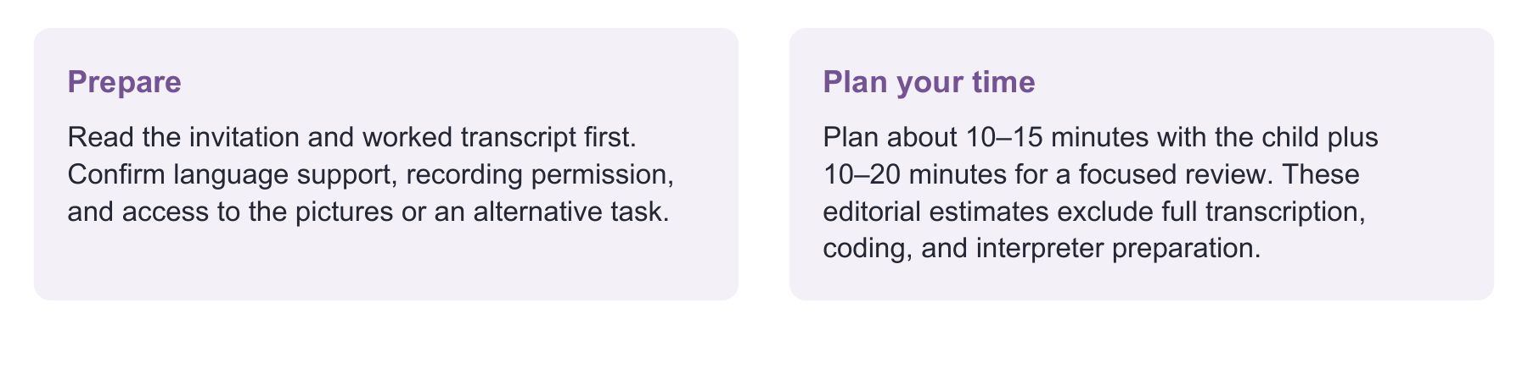
Have ready
Wordless story, sample record, usual communication supports, and an approved recording method when permitted.
Use one focused route
Invite the story → listen → record follow-up prompts separately → review exact examples. Use a familiar activity if the picture task does not fit.
Record enough to decide
Task, language use, access supports, one independent message, one prompted response, and the next context to sample.

Evidence behind the practice
Diagnostic-accuracy meta-analysis supports language sampling within a broader assessment. It does not validate this original story or establish a minimum sample length. [6]
Interpretation limit
A brief sample supports description and planning. A quantitative or reference comparison requires the full matched elicitation and analysis protocol.

02 SESSION CARD

Set up a sample you can interpret
Have ready: the wordless picture page, this record, the child’s communication supports and permission to record.
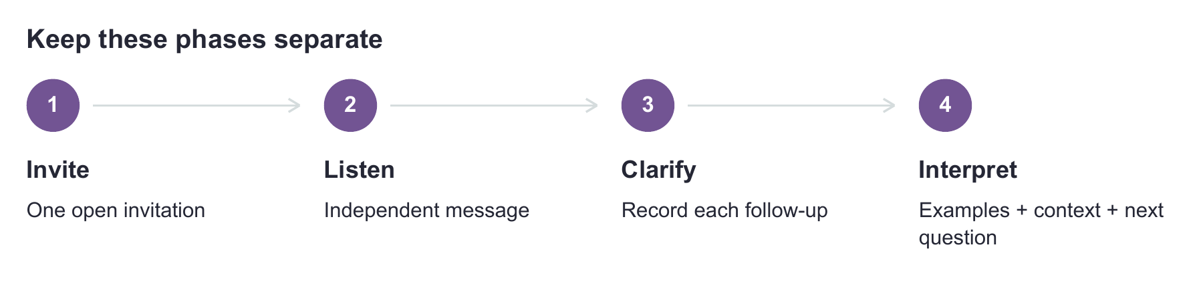
English invitation: Look at all the pictures. Tell me the whole story. You can use Spanish, English, or both.
Original informal story-generation task.
Spanish invitation: Mira todos los dibujos. Cuéntame toda la historia. Puedes usar español, inglés o los dos.
Use the language plan that fits your question; record actual use.
If you see this | Try this next
Child begins telling | Listen without supplying the problem or missing words.
Child stops | Allow processing time. Then “Tell me more” / “Cuéntame más”; label the response as prompted.
Child is quiet or uncomfortable | Offer a familiar activity or partner. If communication remains too limited to interpret, record “insufficient sample” and plan another context.
Child needs access support | Provide usual AAC, positioning and sensory supports; record what was available.

Choose the right task
For emerging communication, use familiar play or routines. For an older student, choose a relevant explanation or personal event. If pictures are not accessible, use a meaningful nonvisual task and name the changed task in the record. [1–3]
Sample before teaching with this story in the dynamic assessment lab; record prior exposure. The story has no norms or cutoff. A flexible bilingual sample describes communication; it does not provide separate proficiency scores. Use the required materials and protocol for a SALT comparison. [1, 5]

03 CHILD FACING PICTURE PAGE

Tell the story
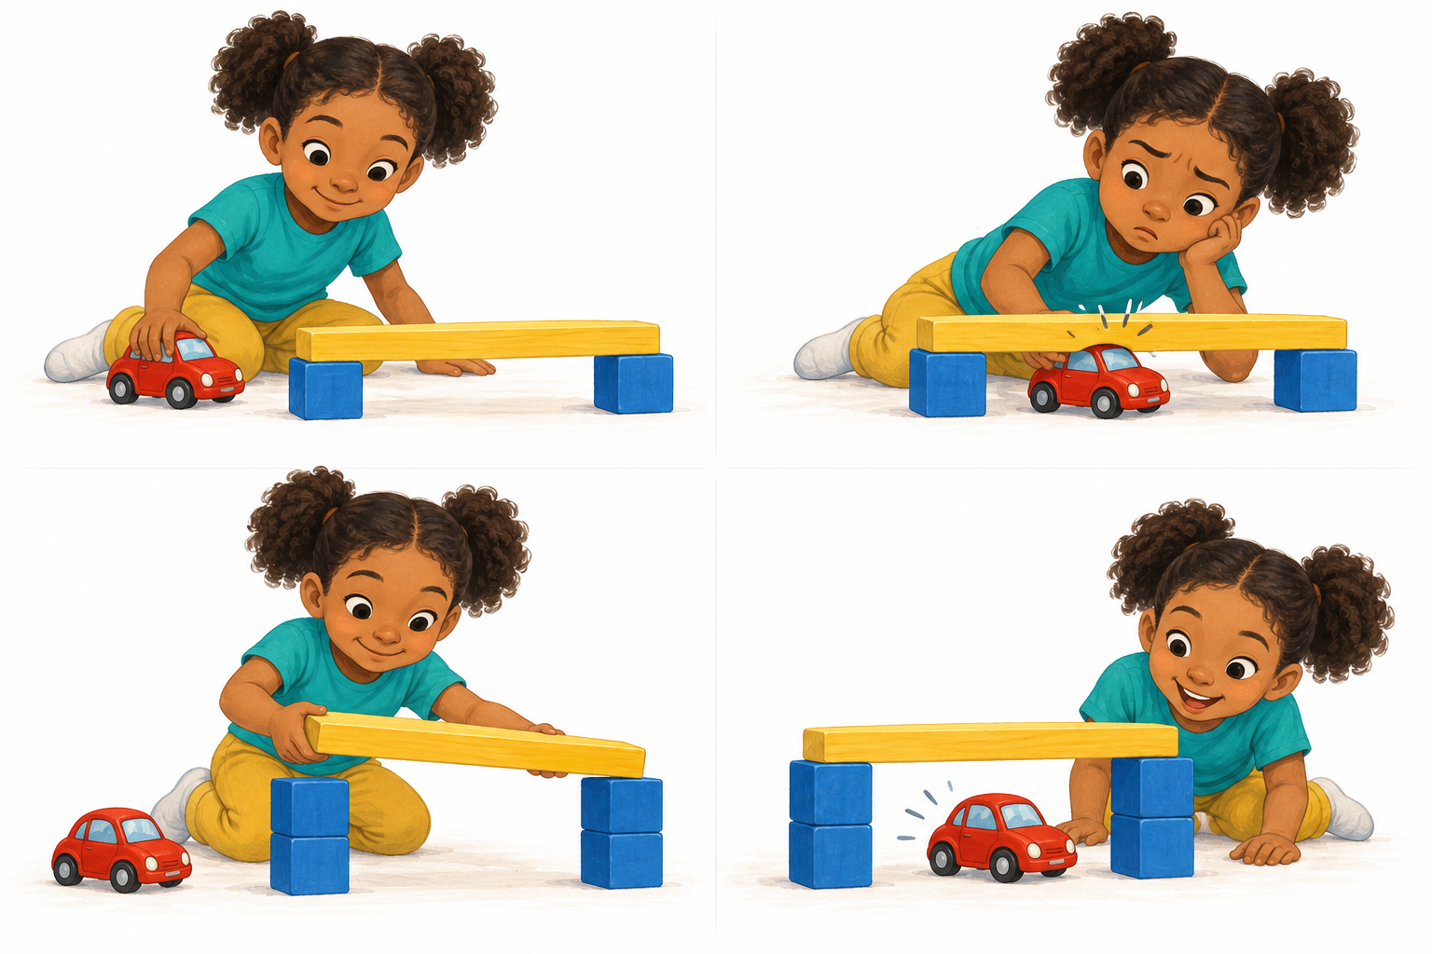

04 FICTIONAL TRAINING TRANSCRIPT

Hear the evidence in the actual words
The following dialogue is invented for clinician practice. It is not an age benchmark or a model answer to require from a child.
Clinician: Cuéntame toda la historia. Puedes usar español, inglés o los dos.
Open invitation.
Child: La niña hizo un puente. El carro no cabe. Puso esos ahí. Then it went under.
Independent story.
Clinician: Cuando dices “esos”, ¿qué puso?
Follow-up after the initial sample.
Child: Los bloques. Más altos.
Prompted clarification; retain separately.
What you hear | What it supports | What to check next
“La niña hizo un puente” | Character and action are explicit. | An action is not necessarily an explicitly stated goal.
“El carro no cabe” | An obstacle is communicated. | Do other tasks show explanations of why?
“Puso esos ahí” | An action with a Spanish implicit subject. | The pictures may make “esos” clear; ask about the referent after sampling.
“Then it went under” | An outcome in English. | Language switching itself is not an error. “It” may be clear with the pictures; check the referent when the listener cannot see them.
“Los bloques. Más altos” | Specific information with a follow-up. | Keep it out of the independent-story record.

Interpretation you can defend
“The child independently communicated actions, an obstacle and an outcome. A follow-up clarified the added objects. The shared pictures may have influenced referent choices. Another context is needed to assess listener clarity.” [1, 2]

05 FILLED CLINICAL RECORD

Turn the sample into a next move
This completed example uses the fictional dialogue in “Hear the evidence in the actual words.”
Record item | Filled example
Task and language plan | Wordless story generation; flexible Spanish/English; pictures visible.
Strength with exact evidence | Problem: “El carro no cabe.” Outcome: “Then it went under.”
Pattern to investigate | “Puso esos ahí” relied on shared visual context.
Support and response | After “¿qué puso?” child specified “Los bloques. Más altos.”
Next opportunity | Ask the child to explain a familiar game to a listener who does not know it. Record what the listener needs clarified.
What remains unknown | Performance in other contexts and each language; no normative or diagnostic conclusion.

Try a second context
English: Teach me how to play a game you know. Imagine I have never played.
Record listener questions after the initial explanation.
Español: Explícame cómo se juega tu juego favorito. Imagínate que nunca lo he jugado.
Choose a familiar activity and confirm the child knows it.

If you count a form
Define the target, eligible contexts, exclusions and prompts. No eligible contexts means “not observed,” not 0%. Before judging a form as an error, check the child’s language variety. For numbers, follow a complete segmentation protocol; Spanish and English mean-length values are not interchangeable. [2, 5]
Repeating the same story in another language adds familiarity. Record order and prior exposure; do not treat the samples as equivalent independent tests. Narrative organization can also vary with task, language and experience. [3, 4]

06 COPY AND USE

Your language sample record
Preserve the child’s exact words, including language switches, and keep translations separate.
Child code / age / date / clinician
________________________________________________________________________________
Languages and varieties / experience / family priority
________________________________________________________________________________
Task / partner / language instructions / AAC and other access supports
________________________________________________________________________________
Task order / prior exposure / duration / recording location
________________________________________________________________________________
Observation | Exact words or communication | Independent or prompted
Message strength
Word or meaning
Sentence or grammatical pattern
Repair or participation

Exact follow-up or model and response
________________________________________________________________________________
________________________________________________________________________________
If counting: measure / analysis unit / correct uses / eligible contexts / exclusions
________________________________________________________________________________
Language or dialect explanation to review / qualified reviewer
________________________________________________________________________________
Interpretation limited to this sample
________________________________________________________________________________
Next task that will answer the remaining question
________________________________________________________________________________

One precise report sentence
“During [task/conditions], the child independently [example]. After [exact support], the child [response]. This suggests [limited interpretation]. We will examine [question] through [next evidence].”

07 SOURCE NOTES

Evidence and materials
Research supports using language samples within a broader bilingual evaluation. It does not validate these original pictures, prompts or worksheets.
Research takeaway: A 2026 meta-analysis included nine studies of children ages 2–7. Accuracy varied, and integrated measures had the highest accuracy. Sampling contributes evidence; it is not automatically diagnostic. No pooled accuracy applies to this practicum. [6]
[1] American Speech-Language-Hearing Association. (n.d.). Multilingual service delivery in audiology and speech-language pathology. Practice Portal. Accessed September 26, 2026. https://www.asha.org/practice-portal/professional-issues/multilingual-service-delivery/
[2] Gutiérrez-Clellen, V. F., & Simon-Cereijido, G. (2009). Using language sampling in clinical assessments with bilingual children: Challenges and future directions. Seminars in Speech and Language, 30(4), 234–245. https://doi.org/10.1055/s-0029-1241722
[3] Fiestas, C. E., & Peña, E. D. (2004). Narrative discourse in bilingual children: Language and task effects. Language, Speech, and Hearing Services in Schools, 35(2), 155–168. https://doi.org/10.1044/0161-1461(2004/016)
[4] Granados Vargas, A., Peña, E. D., & Bedore, L. M. (2024). Bilingual children demonstrate variation within shared narrative macrostructure. Journal of Speech, Language, and Hearing Research, 67(11), 4504–4517. https://doi.org/10.1044/2024_JSLHR-23-00778
[5] SALT Software. (n.d.). Resources and elicitation aids. Includes reference-database protocols and segmentation guidance. Accessed September 26, 2026. https://www.saltsoftware.com/resources and https://www.saltsoftware.com/resources/elicaids
[6] Ortiz, J. A., Chow, J. C., Nolasco, J. M., & Huang, Y. T. (2026). Language sample analysis in bilingual children: A meta-analysis of diagnostic accuracy. American Journal of Speech-Language Pathology, 35(3), 1304–1321. https://doi.org/10.1044/2025_AJSLP-25-00201
Additional materials: LEADERSproject SLAM https://www.leadersproject.org/en/category/slam and Bilinguistics evaluation resources https://bilinguistics.com/evaluation-resources/. Follow each source’s instructions and permissions.
Sources checked 26 September 2026. Record task, language, partner, supports and meaningful examples before interpreting a number.

