START HERE

Selecting vocabulary for bilingual children
Matching useful words to real communication needs
Choose the next useful vocabulary target from a child’s real communication needs, rather than from an age list alone.
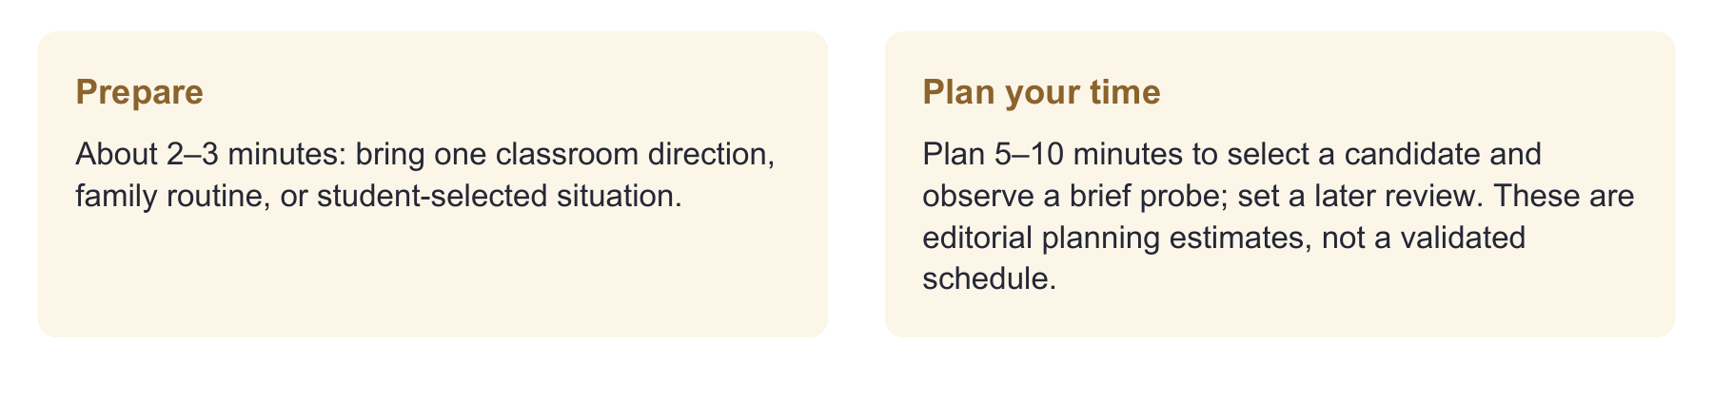
Have ready
The actual task or familiar pictures/objects, input from the child and a partner, and the one-page target record.
Use one focused route
Identify the communication purpose → check meaning and labels in relevant languages → choose one target → plan an example that will show its use.
Record enough to decide
Write what the child already communicates, the exact response in each condition, what support was needed, and why the selected target matters.

Evidence behind the practice
Language-context planning follows professional guidance [1]; a preschool bilingual vocabulary trial supports teaching both relevant languages [2]. Cognate evidence does not validate these age/grade lists [7].
Interpretation limit
These are candidate words and original planning examples, not milestones, norms, or prescribed goals. A different word may better serve the same purpose.

02 CHOOSE A ROUTE

Start with the moment and the purpose
What does this child want to understand, explain, request, or share?
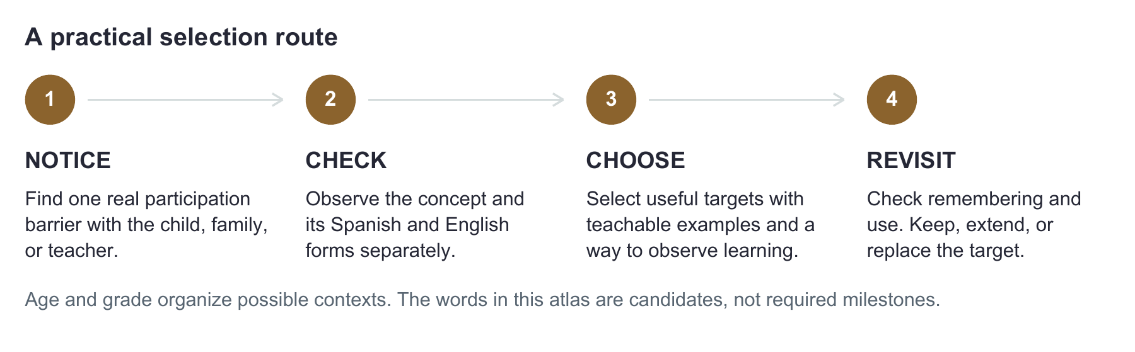
What you observe | What you might teach
Shows the idea in one language; does not recognize a useful label in the other. | Link the relevant label to demonstrated meaning. Either Spanish or English may be the new form.
Uses a word but gives only a vague meaning. | Deepen the meaning with examples, contrasts, and relationships.
Understands but cannot retrieve the useful form. | Plan supported expression and later retrieval.
Has not shown the idea in either language. | Check access and experience; teach the concept and relevant language forms.

FICTIONAL EXAMPLE

Lucía needs a word during play
Family priority: explain why a toy will not move to a sibling who uses both Spanish and English.
Lucía pulls and points to show the problem. Her family uses “atorado”. Check the concept and both labels separately, then select the form useful with that partner. Do not assume Spanish is only for home or English only for school.
Clinical move: Recognize existing communication. Word selection should add a useful option, not erase gesture, AAC, or another language. [1]

03 EARLY CHILDHOOD AND EARLY SCHOOL

From everyday routines to shared stories
Browse by communication purpose. Older children can need these purposes too, with age-respectful activities.
TODDLERS AND EARLY COMMUNICATORS

Join, continue, stop, and share
Contexts: meals, dressing, movement, favorite play, and family routines.
Candidates: más / more; otra vez / again; ayuda / help; no / no; mira / look; abrir / open; names of important people. Choose forms the family actually uses.
Clinical move: Try: follow a familiar activity, notice the child’s message, and model a useful expression. For an older AAC user, the same purpose might be “otra vez” during music. Honor requests to continue or stop; avoid requiring a word before responding.
PRESCHOOL

Explain play and negotiate with others
Contexts: blocks, pretend play, art, and taking turns.
Candidates: cabe / it fits; atorado / stuck; falta uno / one is missing; igual / same; diferente / different; primero / first; después / next; “me toca / my turn”. Use wording that fits the interaction.
Clinical move: Try: build two openings and test which toy fits. Ask the child to tell a partner what happened. Choose “cabe” or another family-preferred form based on the actual interaction.
KINDERGARTEN THROUGH GRADE 2

Retell, describe, and follow a task
Contexts: shared stories, class projects, and problem solving.
Candidates: problema / problem; solución / solution; antes / before; después / after; comparar / compare; explicar / explain; “necesito ayuda / I need help”.
Clinical move: Try: bring a classroom direction. Check the action word separately from the topic words, then practice the task with a concrete example.

CHOOSE, DO NOT ASSIGN
No word here is required at a particular age. Consider interest, access, experience, and current need. The preschool bilingual intervention study supports target learning in its studied context [2]; it does not validate these lists or establish effects from toddlerhood through adolescence. [1,2]

04 LATER ELEMENTARY AND SECONDARY SCHOOL

From classroom ideas to self advocacy
Use actual assignments and student priorities to make the vocabulary relevant.
GRADES 3 THROUGH 5

Explain relationships and evidence
Contexts: science investigations, reading discussion, and social studies.
Candidates: comparar / compare; causa / cause; evidencia / evidence; justificar / justify; hábitat / habitat; evaporar / evaporate. Confirm the meaning used in the current lesson.
Clinical move: Try: ask the teacher for tomorrow’s question. Separate topic knowledge from the instruction word. A student may know habitats yet need help doing what “compare” asks.
GRADES 6 THROUGH 12

Participate, question, and manage learning
Contexts: coursework, group projects, practical tasks, and student-selected goals. Example: a teen uses English at home and Spanish in a dual-language class.
Candidates: analizar / analyze; variable / variable; confiable / reliable; fuente / source; fecha límite / deadline; aclarar / clarify; “necesito un ejemplo / I need an example”.
Clinical move: Try: rehearse “¿Me das un ejemplo?” or “Can you show me an example?” with the student’s chosen partner. The target is getting clarification, not repeating a formal phrase. Check whether it works in the intended class.
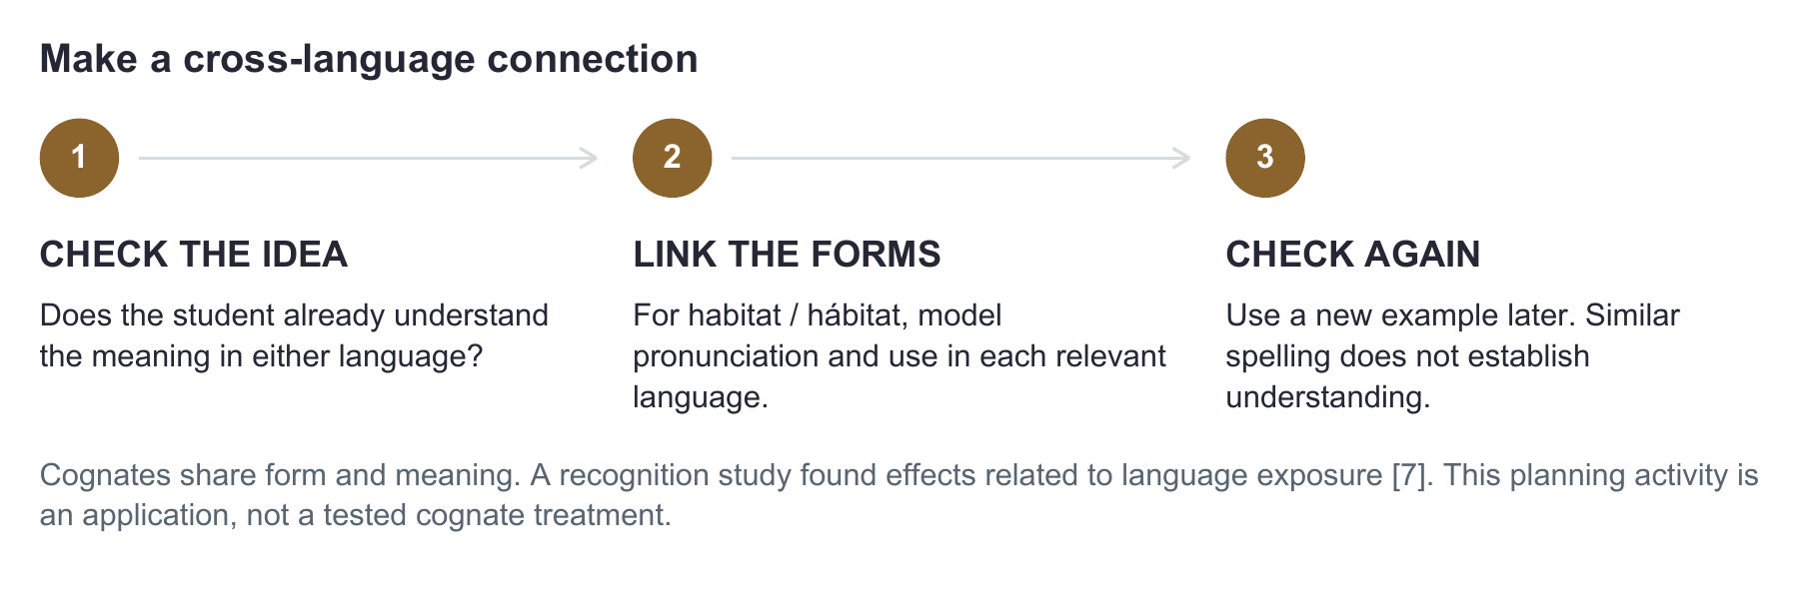

WATCH THE MEANING
“Actually” often means “en realidad”; “actualmente” means “currently”. Similar-looking forms can differ. Verify the intended meaning instead of matching words by appearance.

05 WORKED CLINICAL DECISION

See how the choice changes after a probe
Fictional case: Amara, grade 4, compares habitats in her Spanish science class. She uses English with her father and both languages with her grandmother.
Candidate | What the clinician checks | Decision
hábitat / habitat | Using pictures, Amara explains in English where an animal lives and finds a matching environment. She does not recognize the Spanish prompt “hábitat”. | Link “hábitat” to the concept she demonstrated in English. Do not reteach the whole concept as if it were new.
comparar / compare | With familiar objects and directions in either language, Amara lists features separately but does not state a similarity or difference. | Select comparing as the main task-language target; confirm task comprehension and model one similarity and one difference.
biodiversidad / biodiversity | The term appears in an optional extension, not the current class task. Current knowledge has not been checked. | Hold for later. Do not label it unknown or teach it simply because it looks academic.

MODEL: “Both habitats have plants. This one is wet; that one is dry.” / “En los dos hábitats hay plantas. Este es húmedo; ese es seco”.
TRY: “Tell me one way they are alike and one way they are different.” / “Dime en qué se parecen y en qué son diferentes”.
During teaching, support the comparison as needed. Record the actual help.
CHECK LATER: Show a different pair of familiar environments. Give the planned instruction without the model.
Record the relationship expressed and the language forms separately. A correct fact alone is not a comparison.

HANDOFF TO THE TEACHER
“We are linking hábitat to a concept Amara showed in English and teaching comparar for her science task. With a new pair, note whether she explains a similarity and a difference and what help she receives. Please share her actual words or selections.”

06 COPY AND USE

Your target selection meeting on one page
Bring one real situation. Leave with a target and a way to check its use.
Child code • languages and modes • child, family, or teacher priority
________________________________________________________________________________
Candidate and context | Concept and forms observed | Choose now or later • reason

Selected target • language and mode for this task • observable response
________________________________________________________________________________
Feasible partner action • new example • later review date
________________________________________________________________________________
☐ I know whether the target is a concept, a label, deeper meaning, or use.
☐ The forms match the child’s language context and family usage.
☐ The target has a purpose beyond answering my question.
☐ If knowledge is unclear, I recorded what still needs checking rather than marking it absent.
The age bands, candidate words, cases, and selection route are original planning aids, not developmental norms or a validated treatment package. References inform the principles, not a prescribed list.
[1] American Speech-Language-Hearing Association. (n.d.). Multilingual service delivery in audiology and speech-language pathology. Practice Portal. Retrieved September 26, 2026. https://www.asha.org/practice-portal/professional-issues/multilingual-service-delivery/
[2] Restrepo, M. A., Morgan, G. P., & Thompson, M. S. (2013). The efficacy of a vocabulary intervention for dual-language learners with language impairment. Journal of Speech, Language, and Hearing Research, 56(2), 748–765. https://doi.org/10.1044/1092-4388(2012/11-0173)
[7] Méndez Pérez, A., Peña, E. D., & Bedore, L. M. (2010). Cognates facilitate word recognition in young Spanish–English bilinguals’ test performance. Early Childhood Services, 4(1), 55–67. https://pmc.ncbi.nlm.nih.gov/articles/PMC3615885/

