START HERE

Teaching vocabulary in Spanish and English
A worked lesson with observation and later review
Teach one word that helps a child communicate in a real activity, then check whether it is remembered.
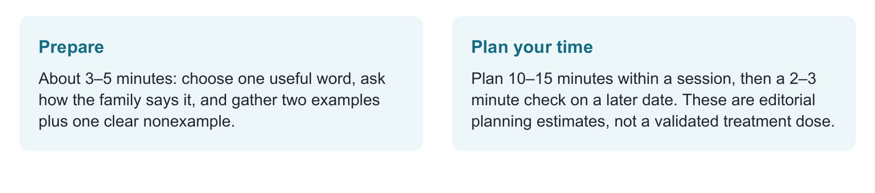
Have ready
Toy car and blocks or the supplied picture, a second blocked object, a freely moving object, and the recording sheet.
Use one focused route
Check meaning and word forms → teach in play → invite recall after another activity → check later. Start with the worked “atorado / stuck” lesson.
Record enough to decide
Tally adult models and recall opportunities separately. Write the exact response, language, and cue. Keep recognition, meaning, and word retrieval distinct.

Evidence behind the practice
A randomized preschool study supports bilingual vocabulary teaching [2]. Retrieval findings depend on the task; a 2025 book-reading study found no benefit from a higher proportion of retrieval opportunities [5,6].
Interpretation limit
This lesson is an adaptation, not the studied treatment package. No universal exposure count, question count, or mastery cutoff applies.

02 START IN PLAY

A word can solve a real problem
Worked target: atorado / stuck. Family usage determines the Spanish form.
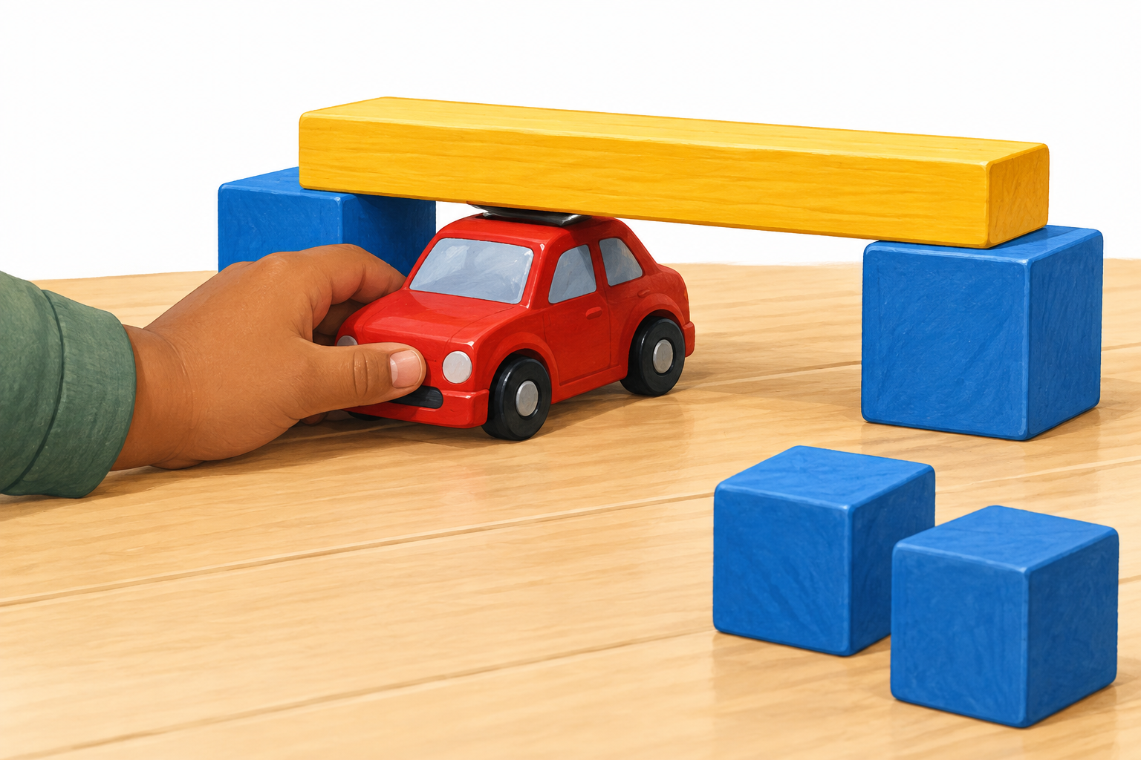
A useful teaching scene: the car is caught under the low bridge and cannot move through.
FICTIONAL CLINICAL EXAMPLE

Lucía wants to explain what went wrong
Lucía plays with her father and older sibling, who use both languages. She points and pulls when a toy cannot move. In this family, “atorado” is familiar wording.
Check whether she can show which toy cannot move or demonstrate the problem. Then check “atorado” and “stuck” separately. Record the gesture or action used to show the idea, even when neither word is produced.
Clinical move: Selected participation goal: communicate that an object is stuck so a play partner understands the problem.

BEFORE YOU TEACH
Agree on useful language forms, check access, and collect a brief baseline. An English word gap alone does not describe the child’s bilingual vocabulary. [1]

03 THE WORD LESSON

Teach meaning then help the child use it
Use the language needed in the interaction. Parallel scripts are options, not a requirement to repeat every sentence twice.
1. Say and show the meaning “Está atorado. Algo no lo deja moverse.” / “It is stuck: it cannot move because something is blocking it.” Move the car gently to show the problem. Use the family’s word, such as “trabado”, when it fits this meaning.
2. Change the example Show a toy figure caught between blocks. Keep the shared idea visible: movement is blocked.
3. Show a nonexample A toy sits in an open space and rolls easily. “Este no está atorado; se mueve.” / “This one is not stuck; it moves.” A closed door is not necessarily stuck; it may open easily.
4. Use the word for a reason A play partner has not seen the problem. “Tell them what happened.” / “Cuéntale qué pasó”. Respond to the message, then model a useful word if needed. Do not make saying the word a condition for help.
CHILD MAY SAY: “Car.”
“Sí, el carrito está atorado. No se puede mover.” Demonstrate the meaning and invite a later try. Use the language selected for this interaction.
CHILD MAY SAY: “No puede salir.”
The meaning is expressed. If the goal includes word retrieval, record that “atorado” was not yet produced.
CHILD MAY SAY: “Está atorado. Help me.”
Acknowledge the message and respond to the request. Record the language forms used.

TEACH ACROSS LANGUAGES
Bilingual vocabulary intervention can support learning in Spanish and English. Select languages with the family and team; check outcomes in each language rather than assuming transfer. [1,2]

04 MATCH THE PROMPT TO THE GOAL

Ask a question that reveals the skill
Different questions answer different clinical questions. This is a menu, not a required developmental ladder.
What you want to know | Try this | What to record
Recognizes the meaning | “Show me which one is stuck.” / “Enséñame cuál está atorado”. | Choices supplied; pointing or selection; cues.
Explains the idea | “What is happening?” / “¿Qué está pasando?” | Meaning expressed, even without the target word.
Recalls the word | After another activity: “What word did we use when the car couldn’t move?” / “¿Qué palabra usamos cuando el carrito no se podía mover?” | Word and language; time since teaching; exact cue. Record an alternate expression as meaning, not target-word recall.
Applies the idea | Present a new caught object: “Tell your partner the problem.” / “Dile cuál es el problema”. | Message, target form, new context, and help.

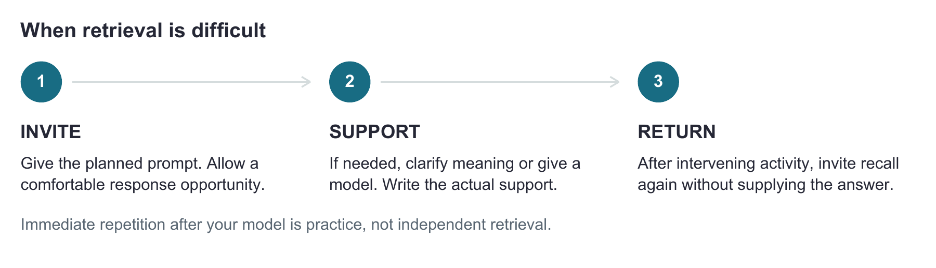

A USEFUL DISTINCTION
If Lucía selects the caught toy from the offered choices but cannot name the problem, she recognized the example in that choice task; word retrieval remains a target. Broader understanding needs other examples. An accurate alternate expression can demonstrate the meaning without the selected word.
Laboratory word-learning studies support retrieval practice [5]. In a 2025 study of 37 kindergarten children with DLD, more within-session retrieval opportunities did not improve learning or retention [6]. Use brief checks to guide teaching; do not turn the activity into repeated quizzing.

05 DOSAGE WITHOUT A MAGIC NUMBER

Count teaching and check remembering
Decide what counts before the session. Models and retrieval opportunities are different events.
Here, one model is one adult presentation of the target word linked to meaning; feedback containing the word adds a model. A recall opportunity starts with the planned prompt. Mark target word recalled without an extra cue, supported response, no response, or alternate wording. Keep the denominator: successful independent recalls / opportunities.
Fictional session | Spanish models | English models | Independent Spanish recall | Independent English recall
1 | 6 | 6 | 0 of 2 | 1 of 2
2 | 6 | 6 | 1 of 2 | 1 of 2
3 | 6 | 6 | 2 of 2 | 2 of 2
Later check, 7 days after session 3 | 0 | 0 | 0 of 1 | 1 of 1

READ THE PATTERN
This fictional example totals 36 adult models, 18 in each language. Counts are not interchangeable with exposures in a published protocol. The later check precedes reteaching. Success did not fully persist: reteach across varied examples, then check again. Do not infer mastery from the total.
The 2017 book-reading study tested 12, 24, 36, and 48 exposures in 27 kindergarten children. The 2019 study used 36 with different schedules and found forgetting after treatment. Neither establishes a universal bilingual dose or supports a rule of “more than 36”. [3,4]
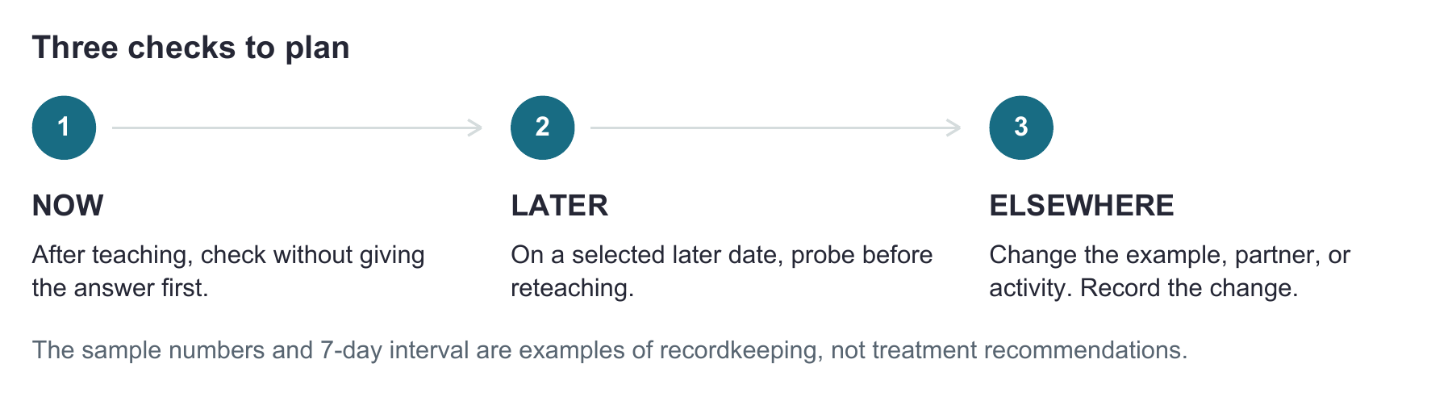

06 COPY AND USE

Build your own one word lesson
Complete a brief plan, then revise it from the child’s response.
Child code and date • participation goal • family or classroom priority
________________________________________________________________________________
________________________________________________________________________________
Spanish and English forms • family preferred wording
________________________________________________________________________________
Baseline: concept / Spanish form / English form / communication mode
________________________________________________________________________________
________________________________________________________________________________
Child-friendly meaning • two examples • one nonexample
________________________________________________________________________________
________________________________________________________________________________
My model • recall prompt • response mode • how I will record support
________________________________________________________________________________
________________________________________________________________________________
Date and language | Models | Recall opportunities | Exact independent or supported response

Later check date • new example • feasible partner practice and language
________________________________________________________________________________
☐ The word serves a real communication need.
☐ I can explain the meaning accurately and show varied examples.
☐ I separated support from independent use.
☐ I checked later remembering and a new context.
Review decision: continue / change support / deepen meaning / select a new target. Why?
________________________________________________________________________________
________________________________________________________________________________

07 SOURCES

Keep the evidence attached to the activity
References support the principles. The lesson and forms are original clinical adaptations.
This coachbook has no validated mastery cutoff or prescribed dose. Studies differ in age, language background, task, and outcome. Use the child’s response, language experience, and participation priorities to guide the next step.
[1] American Speech-Language-Hearing Association. (n.d.). Multilingual service delivery in audiology and speech-language pathology. Practice Portal. Retrieved September 26, 2026. https://www.asha.org/practice-portal/professional-issues/multilingual-service-delivery/
[2] Restrepo, M. A., Morgan, G. P., & Thompson, M. S. (2013). The efficacy of a vocabulary intervention for dual-language learners with language impairment. Journal of Speech, Language, and Hearing Research, 56(2), 748–765. https://doi.org/10.1044/1092-4388(2012/11-0173)
[3] Storkel, H. L., Voelmle, K., Fierro, V., Flake, K., Fleming, K. K., & Swinburne Romine, R. (2017). Interactive book reading to accelerate word learning by kindergarten children with specific language impairment: Identifying an adequate intensity and variation in treatment response. Language, Speech, and Hearing Services in Schools, 48(1), 16–30. https://doi.org/10.1044/2016_LSHSS-16-0014
[4] Storkel, H. L., Komesidou, R., Pezold, M. J., Pitt, A. R., Fleming, K. K., & Swinburne Romine, R. (2019). The impact of dose and dose frequency on word learning by kindergarten children with developmental language disorder during interactive book reading. Language, Speech, and Hearing Services in Schools, 50(4), 518–539. https://doi.org/10.1044/2019_LSHSS-VOIA-18-0131
[5] Leonard, L. B., Deevy, P., Karpicke, J. D., Christ, S. L., & Kueser, J. B. (2020). After initial retrieval practice, more retrieval produces better retention than more study in the word learning of children with developmental language disorder. Journal of Speech, Language, and Hearing Research, 63(8), 2763–2776. https://doi.org/10.1044/2020_JSLHR-20-00105
[6] Gordon, K. R., Moss, D., Swinburne Romine, R. E., Fleming, K. K., & Storkel, H. L. (2025). Interactive book reading to accelerate word learning by kindergarten children with developmental language disorder: Incorporating retrieval-based practice into training. Language, Speech, and Hearing Services in Schools, 56(4), 1110–1125. https://doi.org/10.1044/2025_LSHSS-24-00147

APPLY WITH PRECISION
Direct evidence: the preschool Spanish–English intervention [2]. Indirect evidence: studies with other language/task conditions [3–6]. Their findings inform questions to ask; they do not validate this lesson or show that more exposures or questions always produce more learning.

