11 ORIGINAL SESSION KIT

The Bridge Repair Crew
An English-led vocabulary kit with a cooperative game and Spanish home practice

Run one useful session
An original story, a cooperative build game and a learning record for English vocabulary: sturdy, fragile and repair. Suggested fit: early elementary children, approximately 6–8 years, when these meanings matter to their goals. Age is a planning suggestion, not an eligibility rule.
Have ready | Start here
Print pages 2, 5–7. | Read the story yourself; preselect two or three useful target words.
Two supports; paper strips; tape; wide craft sticks; a toy car or paper token. | Use the paper game board if objects or motor access are a barrier.
A way to point, speak, sign or use AAC. | Show how to choose. The adult may move pieces for the child.

Planning estimate: allow about 20–25 minutes for the English activities, or split them across shorter visits. Preparation and visit times have not been tested in clinics.
The English-speaking SLP leads the English component. Arrange Spanish clinical support through a qualified bilingual SLP or a trained interpreter working with the SLP. Brief the partner on the target, prompts and recording; debrief afterward. A Spanish-speaking caregiver can share priorities and home examples. Home practice supplements, and does not replace, needed Spanish clinical services. [3]

What makes this EBP informed
Explicit meanings, meaningful examples, repeated teaching across visits and progress checks draw on published intervention principles. The story, game, selected words and three-visit sequence are original and have not been tested as a treatment package. [1–3]

Read the story
Read aloud in English. Pause only at the three planned meaning moments on the next page; keep the story enjoyable.
Maya, Leo, and Sam wanted their toy delivery car to cross a pretend river. They put two blocks on the park table and stretched a thin paper bridge between them.
“I think it is ready,” said Leo. Sam rolled the car forward. The paper sagged, and a thin edge tore. The car stopped. Maya caught it before it fell.
“This bridge is fragile,” Maya said. “It can break or become damaged easily. We need something that will hold our car.”
Sam tapped a wide wooden stick. “This feels sturdy. It is strong enough to hold its shape.” He passed the stick to Leo.
Leo looked at their first bridge. “Can we repair it instead of throwing it away?”
“To repair something is to fix it,” Maya said. “Let’s try.”
They laid several sticks across the blocks and taped the paper on top. Maya held one end. Leo added tape. Sam checked that both ends rested on the blocks.
A thin edge of paper tore when Leo pulled it. “That part is still fragile,” he said. He used a small piece of tape to repair the tear.
Now the bridge felt sturdy. Sam moved the car slowly across. It reached the other side. All three children cheered.
“Should we put a heavy rock on it?” Leo asked.
“Wait,” Maya said. “Sturdy does not mean it can hold everything.” They decided to test only their small toy car.
At cleanup, Sam noticed a torn page in their drawing book. “We know how to repair that, too,” he said. Maya held the page flat while Leo found the tape. Their bridge team had one more job.

SHOW SAY WAIT

Make the meaning visible
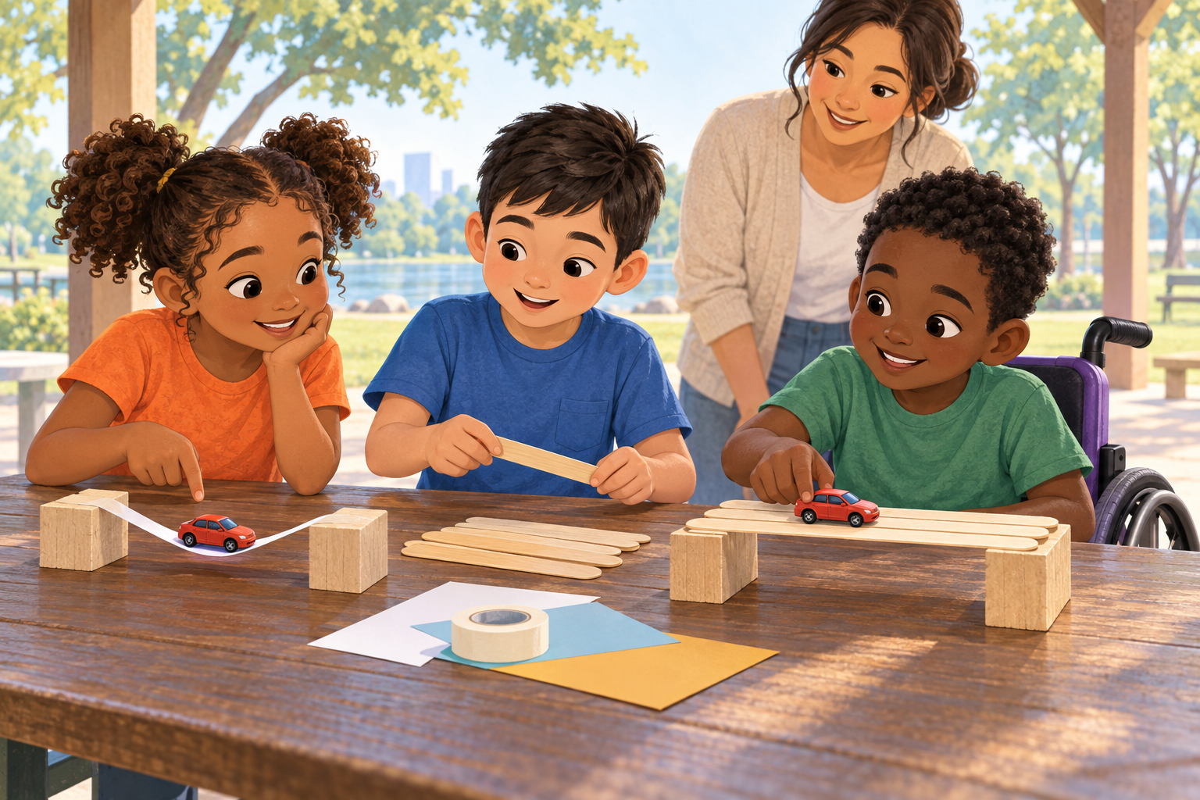
Teaching picture of the bridge supports. Demonstrate fragility with a torn scrap of paper; bending alone can mean flexibility. Do not use teaching materials as independent probes.
Say and show | Invite a response
“Fragile means it can break or become damaged easily. This thin paper tore easily.” Show a tear in a thin scrap of paper. | “What might happen if the car is too heavy?”
“Sturdy means strong and stable enough for this job.” Show the supported bridge. | “Which one would hold this toy car? Show me why.”
“Repair means fix something that is broken or damaged.” Tape a tear. | “What could we repair with this tape?”

Wait for the child’s response. If needed, offer a meaning cue, then a choice, then a model. For “strong,” say: “Yes, strong enough for the job. Sturdy.” Do not require exact definitions or speech as the only way to show understanding.

A plan for three visits
Visit | Do | Observe
1 Build meaning | Start with one unfamiliar example per selected word. Then read, show the meanings and play three turns. Offer about 3 explicit models and 2 retrieval opportunities per word beyond the story. | Record actual models and opportunities. This is a starting plan chosen for this kit, not a research dose.
2 Use the meanings | At a later visit, check recall before teaching. Play the remaining game cards. Add new objects and ask for a reason. Revisit the word after another turn. | Does meaning survive a change of object? Which cue helps? Record the gap between visits.
3 Keep and transfer | Check a new example before any reminder. Ask the child to explain a repair or help choose material for another toy bridge. Review family observations. | Separate recognition, explanation and use of the English label. Plan another cycle if needed.

Research does not supply a magic count
There is no established universal number of exposures for every Spanish–English child with DLD. Restrepo et al. studied a 12-week bilingual program, not this kit. A 2025 English DLD study found that increasing retrieval opportunities within interactive book reading did not improve learning or retention. Count what you do, then check what the child retains. [1, 2]
A response you hear | Your next move
“It strong.” | Honor the meaning: “Yes. It is sturdy.” Do not add an unrelated grammar goal.
“Se rompió.” | Acknowledge the message. Confirm meaning with the language partner; offer “It broke. We can repair it.”
Silence or loss of engagement | Reduce the response demand, model once, let the child choose the next piece, and reassess access.

PRINTABLE COOPERATIVE GAME

Build a bridge together
Cut the six strips below or use six paper strips of your own. Put the board on the table. Place one strip across the river after each card, whether the response is independent, supported or modeled. Everyone completes the bridge together. The game never requires earning access to a turn by speaking correctly.
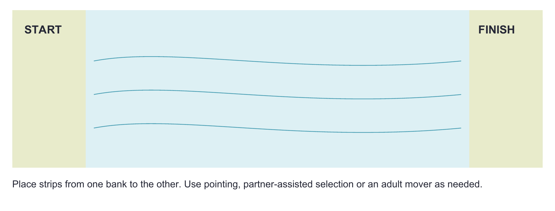
Each turn: choose a card → think or show → hear useful feedback → add a strip. Ask one follow-up only. With a group, rotate chooser, idea giver and builder; everyone can pass. Stop after three cards if attention is fading. Use remaining cards next visit.
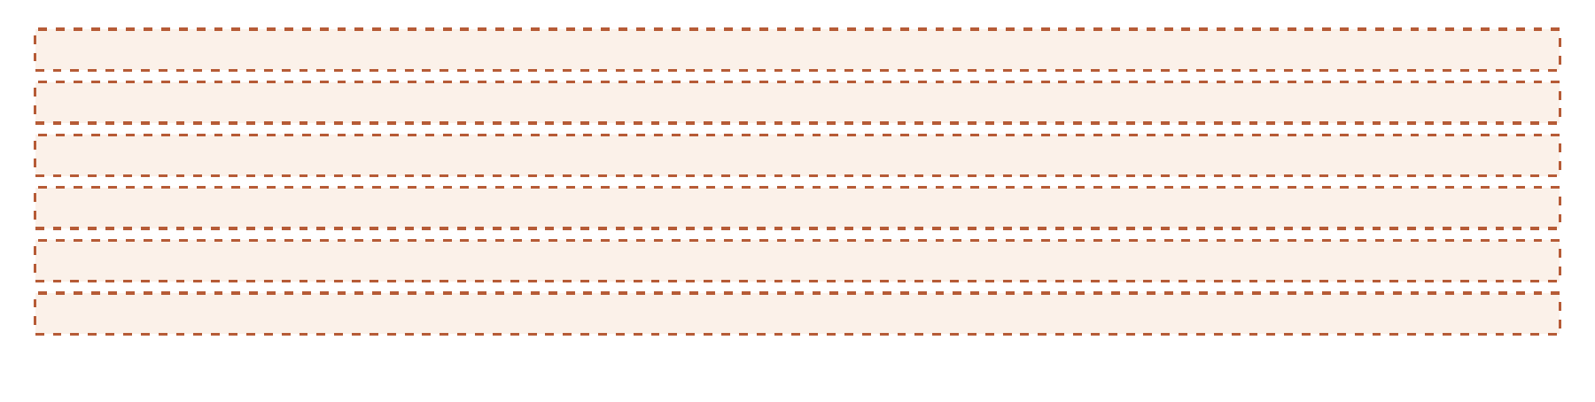
Finish the paper game: move a token along the completed flat route. Optional building extension: with supports, sticks and tape, build a separate raised toy bridge and roll a small toy car across. Explain the material choice. Never test it with a person or heavy object.

CUT OR POINT NO READING REQUIRED

Choose a repair challenge
1 The torn roof  A paper toy house has a thin roof. The paper tears when a toy lands on it. Describe what happened. | 2 Two boxes  One box collapses when you press it gently. Another keeps its shape. Choose one for a heavy toy and tell why.
3 The torn page  A page in a drawing book has a tear. What could you do so the book can still be used? | 4 The thin wrapping  Thin paper wrapped around a book tears easily. Describe the paper. What could protect the book better?
5 The loose wheel  A toy car has a wheel that came off. What is the job: fix this car, or make a new car? Tell your plan. | 6 A new bridge  Choose paper, sticks, or both for a toy bridge. Explain what makes your choice work for the toy.

Adult guide
1 and 4 invite fragile; 2 and 6 invite sturdy; 3 and 5 invite repair. Other meaningful answers are welcome. Recast once with the target word. Cards are teaching opportunities, not standardized test items.

Record learning across visits
Use an anonymous local code if needed. Avoid identifiers when sharing a completed sheet.
Word | Models given | Retrieval opportunities | Independent meaning / English form | Next step
sturdy
fragile
repair

Tally a model when the adult says the word with a meaning, contrast or action. Count a recall opportunity when you invite recall before giving the answer, including no response. Record independent successes / opportunities. Hearing a word in the story is a separate encounter, not automatically an explicit teaching episode.
Date / word | Prompt or new example | Exact response and language | Support and context

Codes for description only: I = independent before cue; S = after semantic cue or choice; M = after spoken model; NR = no response. Accept gesture or AAC for a meaning response. Record the English spoken/AAC label separately. A correct Spanish label may show knowledge of the concept; verify its meaning with a qualified language partner. Do not code it as an English naming response.

Use the next visit to decide
Before reteaching, try a different example without showing the teaching card. If meaning is present but the English label is unavailable, model the label without reteaching the whole concept. If learning disappears between visits, add spaced revisits and supported examples. Check access, fatigue and word relevance before increasing demands.

PARA LLEVAR A CASA

Una misión para hacer en casa
Nuestra misión: descubrir qué resiste, qué es frágil y qué podemos arreglar.
En la sesión compartimos un cuento sobre tres niños que arreglan un puente de juguete. En casa pueden conversar en español, en inglés o usando ambos idiomas. No hace falta que su niño repita palabras en inglés.

Elija un momento de unos cinco minutos
Pueden mirar un libro, guardar juguetes o preparar una mochila. Use objetos seguros que ya tengan. Usted elige cuándo hacerlo; no hace falta completar una tarea todos los días.
Una idea para conversar | Algo que puede decir
Resistente: aguanta bien el peso en este juego. | “Esta caja es resistente. Podemos poner estos juguetes encima.”
Frágil: se puede romper o dañar con facilidad. | “Esta hoja es frágil. Vamos a tratarla con cuidado.”
Reparar: arreglar algo que se dañó. | “Esta página se rompió. Podemos repararla con cinta.”

1. Elijan un objeto. Comente algo sobre él y deje tiempo para responder.
2. Invite a su niño a mostrar, señalar, contar o usar su sistema de comunicación. Si necesita ayuda, muestre usted una idea.
3. En otro momento, vuelvan a hablar de algo parecido. No hace falta hacer muchas preguntas seguidas.
Si dice “arreglar” en vez de “reparar”, esa respuesta también comunica la idea. Use las palabras habituales de su familia. No rompan nada para practicar.
Algo que dijo, señaló o hizo durante el juego
________________________________________________________________________________
________________________________________________________________________________
Algo que quiero compartir con el terapeuta
________________________________________________________________________________

Why these choices
Direct bilingual evidence: Restrepo et al. studied preschool dual-language learners with language impairment using a substantial bilingual vocabulary program. That supports planning for both languages; it does not validate this story, these words or an early-elementary three-visit dose. [1]
Indirect evidence: Gordon et al. studied kindergarten children with DLD in an English book-reading intervention. More retrieval practice within that study did not produce superior word learning or retention. Its findings argue against treating a count alone as a guarantee. [2]
Access and fit: choose targets from a child’s actual participation goals; ask which concepts and forms are already available in each language. Offer large print, a verbal description of the illustration, real objects and familiar AAC vocabulary. Do not remove AAC or require eye contact. [3]
Picture review: fictional children have equal problem-solving roles. Wheelchair use is incidental to participation. No appearance is assigned a language, nationality or diagnosis. The AI-generated image is a teaching illustration, not evidence of intervention effectiveness.
[1] Restrepo, M. A., Morgan, G. P., & Thompson, M. S. (2013). The efficacy of a vocabulary intervention for dual-language learners with language impairment. Journal of Speech, Language, and Hearing Research, 56, 748–765. https://doi.org/10.1044/1092-4388(2012/11-0173) Full text: https://files.eric.ed.gov/fulltext/ED652204.pdf
[2] Gordon, K. R., Moss, D., Swinburne Romine, R. E., Fleming, K. K., & Storkel, H. L. (2025). Interactive book reading to accelerate word learning by kindergarten children with developmental language disorder: Incorporating retrieval-based practice into training. Language, Speech, and Hearing Services in Schools, 56(4), 1110–1125. https://doi.org/10.1044/2025_LSHSS-24-00147
[3] American Speech-Language-Hearing Association. Multilingual service delivery in audiology and speech-language pathology. Practice Portal. Accessed September 26, 2026. https://www.asha.org/practice-portal/professional-issues/multilingual-service-delivery/

Sharing this kit
Original BEaR Lab educational resource. The underlying studies and commercial tests keep their own rights. For individualized clinical decisions, use the child’s evaluation, family priorities and qualified clinical judgment. This kit is not a diagnostic instrument.

