12 ORIGINAL SESSION KIT

The Missing Map
An English-led vocabulary and narrative kit with an information-gap game and Spanish home practice

A mystery with a purpose
An original English story and information-gap game for notice, compare and explain, plus a causal retell. Suggested fit: approximately ages 8–10 when these words and tasks match the child’s goals. Read aloud; decoding skill is not required.
Have ready | Choose one main goal
Pages 2–7; a folder to hide clue cards; four location cards; a token. | Vocabulary: explain a meaning with an example; OR narrative: connect a problem, action and result.
Optional real paper, book, and small object. | Do not score vocabulary and narrative as one combined ability. Accept the child’s communication mode.

Planning estimate: 20–25 minutes per visit, adjustable. Use one story session, one game session and a later transfer check. This sequence and timing are original planning choices, not a validated dosage.
The English-speaking SLP leads the English component. Arrange Spanish clinical support through a qualified bilingual SLP or a trained interpreter working with the SLP. Brief the partner on the target, prompts and recording; debrief afterward. A Spanish-speaking caregiver can share priorities and home examples. Home practice supplements, and does not replace, needed Spanish clinical services. [3]

What you can learn
Track whether the child distinguishes what was observed from what was inferred and can communicate a useful reason. A different explanation can be valid when it fits the evidence. These activities are teaching and monitoring tools, not a DLD screen. [1, 3]

Read the mystery
Pause after “the map was gone.” Invite one prediction. Continue the story without turning every sentence into a test.
Amara and Nico had drawn a yellow map for their library’s neighborhood walk. It showed the library, the garden, and a bench where the group could rest. They left the folded map on a small table by the window.
When they came back, the map was gone.
“Let’s notice what is different,” said Amara. “Notice means pay attention to something.”
Nico looked around. “The window is open now. The curtain is moving, and the papers are scattered.”
“Those are clues,” said Amara. “But they do not tell us everything.”
They decided to compare three places: the table, the bookcase, and the bench. To compare them, they looked for what was the same and what was different.
The table had white papers, but no yellow paper. The bookcase had books on every shelf. Under the bench, Amara saw a small yellow corner.
“I notice something yellow,” she said. “It might be our map, or it might be another paper.”
Nico reached under the bench and picked it up. They opened it. There were their library, garden, and resting bench.
“Now we can explain what we found,” Nico said. “Explain means make an idea clear with details.”
Amara said, “We found our map under the bench. It has the same places we drew.”
“Did the wind move it?” Nico asked.
“Maybe,” said Amara. “The open window and scattered papers make that possible. We did not see it happen.”
They closed the window with the librarian’s help and put the map in a folder. Then they walked through their route with the librarian to check that everyone could use it.

See a clue and build a reason
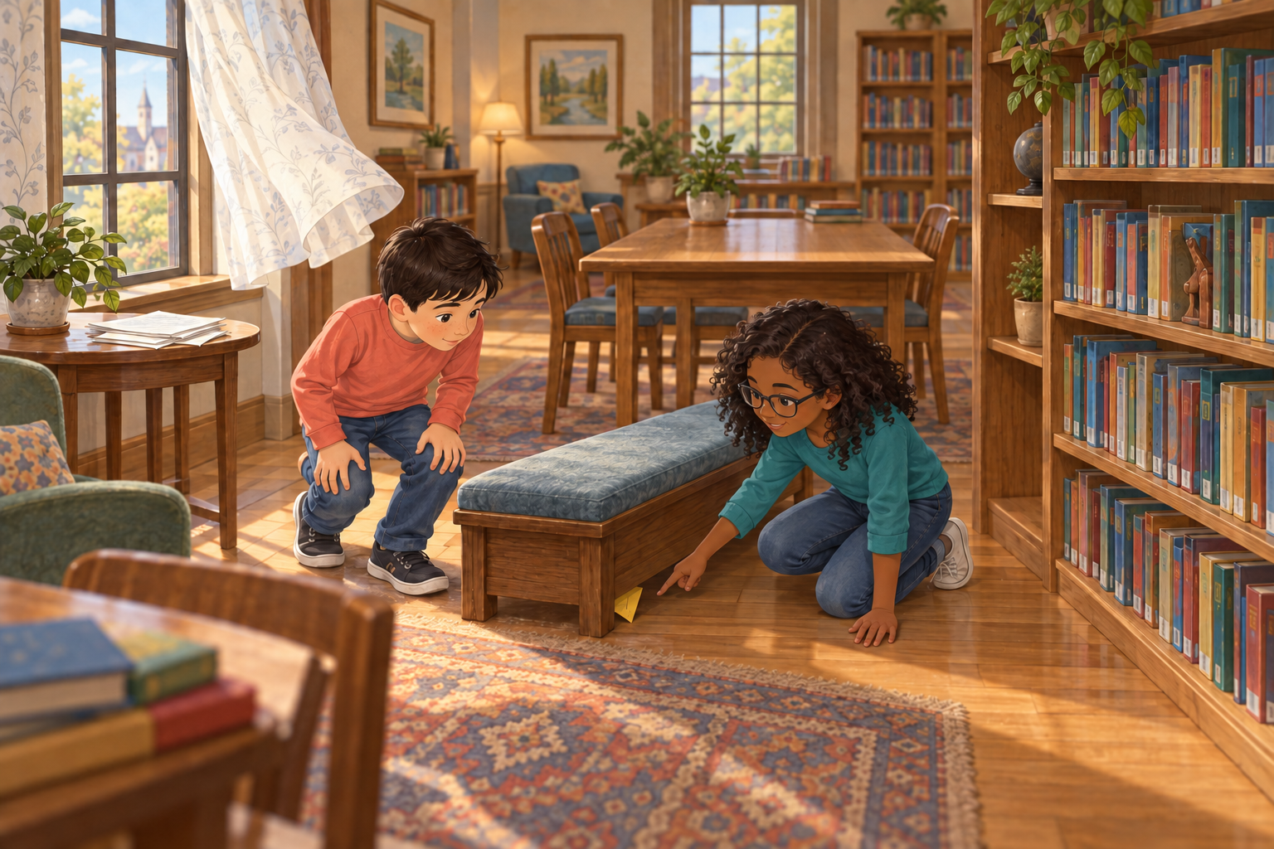
Teaching illustration. The yellow paper is visible; save a different scenario for independent probes.
Meaning | Model then invite
Notice: pay attention to a detail. | “I notice the curtain moving. What else do you notice?”
Compare: look for what is the same and different. | “The table and bench can hold things. One is tall and one is low. Compare two places.”
Explain: make an idea clear with details. | “They knew it was their map because it showed their route. Explain how they knew.”

If the child points, describe the detail and offer an English word model. If the child says “wind did it,” respond: “That could explain it. Which clues support your idea? What part did we not see?” Model uncertainty as a useful language skill.

ORIGINAL INFORMATION GAP GAME

Play the Hidden Location game
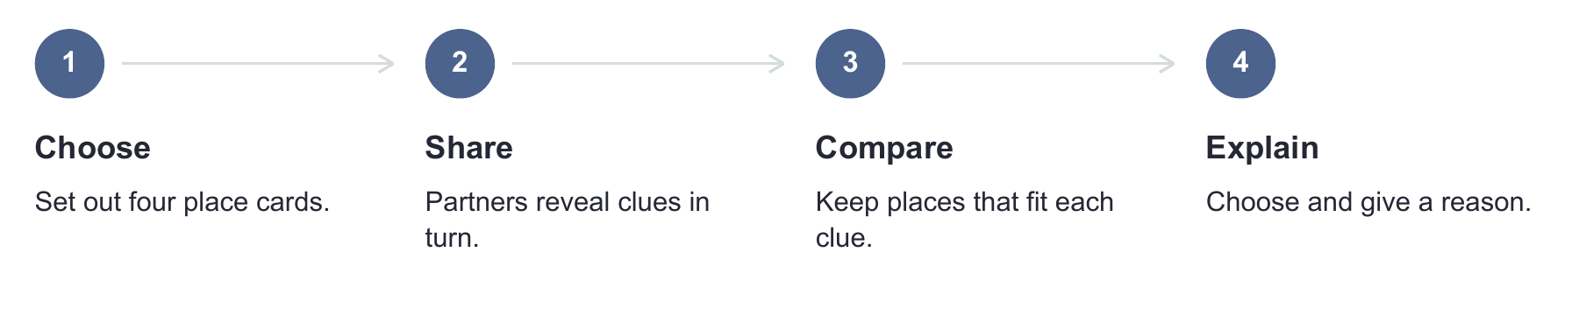
Set up: keep the story illustration out of sight. Put the TABLE, BENCH, BOOKCASE and LOW SHELF cards face up. The adult hides one round’s two clue cards in a folder. Assign clue 1 to the child and clue 2 to the adult; keep the reveal row covered. Read privately to the child if needed. Each partner has information the other needs.
1. The first partner shares or shows their clue. Both point to every place that could fit it. A clue may fit more than one place.
2. The second partner adds their clue. Compare it with the first. Ask: “Which place fits both clues?”
3. Invite an explanation using words, pointing or AAC. Then read the matching reveal row. Change roles for the next round.

Keep the thinking visible
Use tokens to mark possible places, not to reward correct speech. No one loses a turn. For fewer choices, use two places and explain that you changed the task. For greater challenge, let the child make a new clue after the game.
Round | Adult key
A | BOOKCASE: tall and has shelves.
B | BENCH: low, with a flat top and no shelves.
C | TABLE: tall, with a flat top and no shelves.

These location definitions belong to the cards in this game. A real bench, table or bookcase may look different. Discuss a sensible alternative instead of marking it wrong.

PRINTABLE PLACE CARDS

Four places to compare
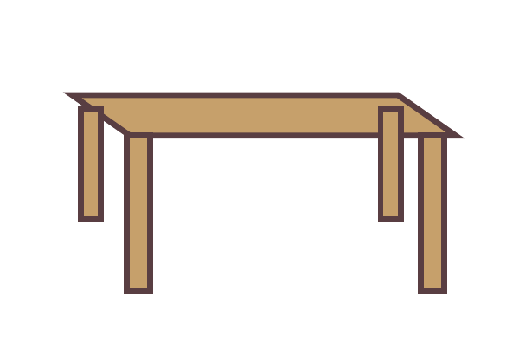  TABLE  Tall • a flat top • no shelves |   BENCH  Low • a flat top • no shelves
  BOOKCASE  Tall • shelves for books • not a seat | 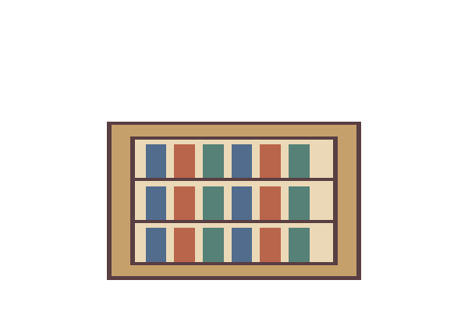  LOW SHELF  Low • shelves for books • not a seat

Place cards are visible during the game. Read the features aloud or describe the drawings. They are supports for reasoning, not hidden test answers. Use the same meanings when reading the clue cards.

CUT OR COVER

Clues for three rounds
A1 Tell your partner  The hidden token is at a tall place. | A2 Add a clue  This place has shelves.
B1 Tell your partner  The hidden token is at a low place. | B2 Add a clue  This place has a flat top and no shelves.
C1 Tell your partner  The hidden token is at a tall place. | C2 Add a clue  This place has a flat top and no shelves.

Keep these reveals hidden | Read after the explanation
A3 | The token is at the BOOKCASE.
B3 | The token is at the BENCH.
C3 | The token is at the TABLE.

Adult: cut or cover each row of clues so partners cannot see both at once. A partner can communicate by reading, retelling, pointing to a shared support or having the adult read their card aloud. The point is sharing information, not keeping a child from needed access.

Teach now and check later
Visit | Action | Record
1 Story and meanings | Model each word in context. Offer about 2 retrieval opportunities per selected word, with feedback. Retell the problem, search and result. | Count actual meaningful models and retrieval opportunities separately. This number is a starting plan, not a required dose.
2 Hidden Location game | Before a reminder, ask for a new example of each word. Then play 1–3 rounds with supports. | Record independent versus supported responses, exact language and useful details.
3 New situation | Show two different objects. Ask what the child notices, how they compare, and why one suits a job. A retell of the practiced story checks retention. For narrative transfer, invite a different familiar event and note any prompts. | Compare with earlier responses and the family example. Keep vocabulary and retell observations separate.

Word / date | Models / retrieval opportunities | Exact response and language | Cue / next step
notice
compare
explain

For narrative, record whether the child communicated: a problem, an action, a result, and a meaningful causal link. These are observations, not a total diagnostic score. For vocabulary, record meaning separately from the English word form. Count a retrieval opportunity even if there is no response; record independent successes / opportunities.

Dose is more than a count
There is no established universal number of exposures for every Spanish–English child with DLD. Restrepo et al. studied a 12-week bilingual program, not this kit. A 2025 English DLD study found that increasing retrieval opportunities within interactive book reading did not improve learning or retention. Count what you do, then check what the child retains. [1, 2]

PARA LLEVAR A CASA

Un pequeño misterio en casa
La meta es conversar y compartir pistas. No es un examen.
En la sesión leímos un cuento sobre un mapa que apareció debajo de un banco de la biblioteca. Los niños observaron detalles, compararon lugares y explicaron lo que encontraron. También reconocieron cuándo una idea era solo una posibilidad.

Jueguen con algo que ya tengan
Elija un objeto conocido y póngalo donde se pueda ver, por ejemplo junto a un libro o sobre una silla. Invite a buscarlo y dé una pista. Si hace falta, señale dos lugares posibles. No esconda algo que su niño necesite ni lo deje fuera de su alcance para obligarlo a pedirlo.
Pueden practicar estas ideas | Una forma natural de decirlo
Fijarse en un detalle | “Mira con calma. ¿Qué ves?” “Yo me fijé en esa esquina amarilla.”
Comparar | “¿En qué se parecen estos dos lugares? ¿En qué son diferentes?”
Explicar con una razón | “Cuéntame cómo lo encontraste.” “Creo que está ahí porque…”

Acepte que su niño hable, señale, muestre o use su sistema de comunicación. Escuche su idea antes de dar otra pista. Si no sabe qué decir, usted puede dar un ejemplo breve y seguir jugando. No hace falta repetir las palabras exactas de la sesión.
Cuando terminen, cuenten juntos qué buscaban, qué hicieron y dónde lo encontraron. Pueden probar unos cinco minutos o parar antes si prefieren.
Una pista que nos ayudó
________________________________________________________________________________
Algo que dijo, señaló o explicó durante el juego
________________________________________________________________________________
________________________________________________________________________________

Evidence and adaptation
The English story, clue game and three-visit schedule are original BEaR Lab activities. The kit combines explicit vocabulary teaching, supported opportunities to use meanings, a short narrative structure and a later transfer check. Its effectiveness as a package has not been tested.
Restrepo et al. provide direct Spanish–English evidence for a much longer preschool vocabulary program, not for this older-child game. Gordon et al. provide indirect English DLD evidence that more retrieval within book reading is not automatically better. Neither study establishes a universal exposure target. [1, 2]
Narrative evidence is more specific: a four-child Spanish–English DLD study of Story Champs found retell story-grammar effects for three children overall, with variability and no established efficacy for the other outcomes studied. Our brief retell activity is not Story Champs and is not a validated inference intervention. [4]
A qualified Spanish-language collaborator should help interpret Spanish responses and coordinate clinical targets. Natural Spanish family practice builds a connection to everyday use; it does not establish cross-language transfer by itself. [3]

Adjust the demand without losing the purpose
Shorten the story or read in two parts. Offer real objects, larger print, AAC, a spoken scene description and partner-assisted pointing. If memory demands obscure reasoning, leave the clues visible and record that support. Ask about familiar words for seats and shelves instead of assuming the same label in every home.
[1] Restrepo, M. A., Morgan, G. P., & Thompson, M. S. (2013). The efficacy of a vocabulary intervention for dual-language learners with language impairment. Journal of Speech, Language, and Hearing Research, 56, 748–765. https://doi.org/10.1044/1092-4388(2012/11-0173) Full text: https://files.eric.ed.gov/fulltext/ED652204.pdf
[2] Gordon, K. R., Moss, D., Swinburne Romine, R. E., Fleming, K. K., & Storkel, H. L. (2025). Interactive book reading to accelerate word learning by kindergarten children with developmental language disorder: Incorporating retrieval-based practice into training. Language, Speech, and Hearing Services in Schools, 56(4), 1110–1125. https://doi.org/10.1044/2025_LSHSS-24-00147
[3] American Speech-Language-Hearing Association. Multilingual service delivery in audiology and speech-language pathology. Practice Portal. Accessed September 26, 2026. https://www.asha.org/practice-portal/professional-issues/multilingual-service-delivery/
[4] Risueño, R. J., Gray, S., & Romeo, S. (2024). The efficacy of Story Champs for improving oral language in third-grade Spanish–English bilingual students with developmental language disorder. Language, Speech, and Hearing Services in Schools, 55(3), 938–958. https://doi.org/10.1044/2024_LSHSS-23-00121

