START HERE

La maleta de las sorpresas
An original Spanish agreement game with a separate family practice page
Help a partner pack the right object by saying what it is and describing it. Choose one agreement target, then check whether it appears beyond the game.
Choose the target | What to listen for
Article with noun | el zapato / la pelota. Also accept a context-appropriate un or una that agrees.
Adjective with noun | zapato rojo / pelota roja. Record this separately from the article.

Suggested fit: children who use Spanish phrases and have an individually established need for this goal. Ages 5–8 are a planning suggestion, not a developmental cutoff. Confirm familiar vocabulary and the family’s words before choosing targets.
Have ready: cards on page 5, scissors, a bag or envelope, page 4 as the packing mat, and page 6 for recording. Real objects can replace pictures. No toy purchase is needed.
Plan one short session: check before teaching; model one target; play up to eight turns; check a different context later. A 15–20 minute slot is an estimate for planning, not tested feasibility or an effective-dose claim.

Who leads the Spanish work
A qualified Spanish-speaking SLP or a clinician working with appropriate interpreter and bilingual clinical support plans, presents, and interprets the Spanish targets. An English-speaking SLP can prepare materials, coordinate, and run the English activity on page 7. Reading this script does not establish Spanish clinical proficiency. [1–2]
Evidence status: this game is original and evidence-informed. Published studies support investigating contextual grammar teaching and explicit plus implicit methods; they do not validate this game or a dose for Spanish gender agreement. [3–4]

01 CLINICIAN ONLY

Check before you teach
Collect a brief starting sample before showing answer phrases, article strips, models, or corrective feedback. This is a progress check, not a diagnostic test.
1. Confirm the child knows each object and the color concept. Use caregiver information or prior observations when possible. If a word is unfamiliar, record that fact; teach it later and select another familiar object for the agreement check.
2. Use pictures or real objects. Hide all printed words. Present one item at a time in a changed order. Say: “Vamos a guardar estas cosas. Dime qué es y de qué color es.” If only a word is given, use one neutral prompt: “Dímelo con más palabras.”
3. Write the first response verbatim. Do not supply el, la, rojo, or roja. Record an omitted article separately from a mismatched article. A single color word or a natural “el rojo” does not provide the full target context; mark not elicited, rather than a gender error.
4. Probe the same familiar items before teaching on a later visit. Separately check different familiar items or a new activity for transfer. Keep prompts and cue conditions comparable and record the interval.
Clinician answer key | Clinician answer key
el zapato rojo | la pelota roja
el vaso rojo | la mochila roja
el plato rojo | la cuchara roja
el sombrero rojo | la toalla roja

Keep the question narrow
A correct article with an incorrect adjective is partial success. Record the two agreements separately. Do not infer DLD, Spanish loss, or intervention need from these eight items. Consider language experience, dialect, broader assessment, and participation needs. [1,5]
If the family uses another noun, honor it and update the expected article and adjective. For example, el bulto rojo and la mochila roja can describe the same kind of object. Do not score the family’s noun as wrong.

02 SPANISH LEADER SCRIPT

Teach one contrast at a time
Start with the child’s chosen object. Keep the exchange about getting ready for an adventure.
Your focus today | Say and show
Article agreement | “Mira: la pelota. Voy a guardar la pelota. Ahora mira: el zapato. Voy a guardar el zapato.” Point to each object.
Adjective agreement | “El zapato es rojo. La pelota es roja. Escucha cómo cambia la última parte: rojo, roja.” Use this explanation only if helpful to the child.

Adult: “¿Qué quieres guardar? Dime qué es y de qué color es.”
Allow time for the first attempt. Record before giving help.
Child: “La pelota rojo.”
Illustrative response, not a diagnostic example.
Adult: “Sí, la pelota roja. La guardamos aquí.”
Confirm meaning and provide the agreed target form. Do not require repetition every time.
If help is useful: “Escucha: pelota roja. Ahora puedes decirlo tú.”
One optional supported try. Mark imitation; do not count it as independent use.
Later in play: “Ahora me toca guardar algo. ¿Qué me das?”
A fresh opportunity after another turn, without immediately supplying the target.

Know exactly what the child did
Use I for an independent first attempt, C for a response after a cue, and M for imitation of a model. Keep correct responses after help separate from independent agreement. A warm recast is teaching, not a new baseline trial.
Do not teach a universal ending rule. Many familiar nouns fit the -o / -a pattern, but Spanish has exceptions. Teach each noun with its article. Grammatical gender here describes words and agreement, not who may own or use an object. [6]

03 COOPERATIVE GAME

Pack the shared adventure bag
Both players win when four cards are in the bag and each person has helped the other choose an object. Mark the four spaces below to track progress. There is no penalty for needing language support.
1. Put the eight cards face up. Choose one mission below. One player gives the clue; the other chooses and requests an object by name, adding its color when that is the target.
2. The Spanish leader models once if needed. Place the card inside the bag even when support was needed, then mark one numbered space below. Switch roles. The child may invent another sensible use for an object.
3. Mark four spaces together. Unpack, choose a new mission, and play a second round only if useful. Eight turns is a convenient game plan, not a required treatment dose.
Vamos a comer afuera  “Necesitamos algo para beber, algo para servir comida o algo para comer.” | Vamos a jugar afuera  “Necesitamos algo para jugar, algo para llevar nuestras cosas o algo para cubrirnos del sol.”
Algo se mojó  “Busca algo que nos ayude a secar.” | Misión inventada  “¿Adónde vamos? Elige un objeto y cuéntame cómo lo usaremos.”

MARCA UN ESPACIO | MARCA UN ESPACIO
1 | 2
3 | 4

Make the exchange real: place the chosen card inside the bag. If a partner is unsure, ask “¿Cuál?” The clinician still records whether the target was independent, cued, or modeled.

04 PRINT AND CUT

Cards for the adventure
All objects are red so color does not signal grammatical gender. Fold or cover each printed label during the starting check. Use the family’s word when it differs.
  zapato |   vaso
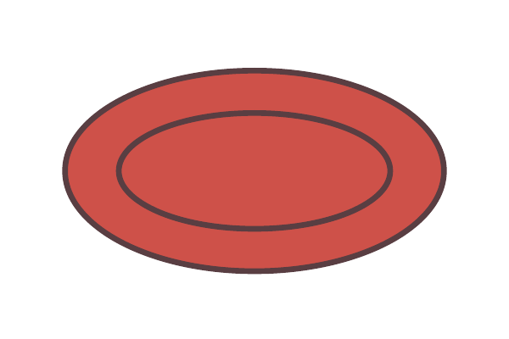  plato |   sombrero
  pelota |   mochila
  cuchara |   toalla

During teaching, the Spanish leader uses the answer key on page 2. The child does not need to read. Replace a picture with a familiar real object whenever that makes its meaning clearer.

05 COPY FOR EACH CHECK OR SESSION

Record the response and support
Do not mix independent checks with supported game turns. Use one copy per condition and record the actual noun used.
Date and child code | Spanish leader | Before teaching / Game / Later check / Transfer
________________________________________________________________________________
Object | Exact response | Article | Adjective | Help
zapato
vaso
plato
sombrero
pelota
mochila
cuchara
toalla

Agreement codes: + = agrees; G = gender mismatch; O = omitted in an elicited context; X = target not elicited, unknown word, or response not interpretable. Add the reason for X. Help: I = independent; C = cue; M = model or imitation. Note any number error separately.
Report counts transparently: e.g., article agreement 5/6 elicited, interpretable contexts; 1 omitted; 2/8 items not elicited. For adjective gender, score only a produced adjective that can mark gender, such as rojo/roja. Grande or azul does not show this contrast; mark X for this target, not an error.
Actual teaching dose | Adult target models or recasts | Child opportunities | Independent / cued / imitated attempts
________________________________________________________________________________
________________________________________________________________________________
Next step | What changed outside the game | Family words and feedback | Unknown words or X reasons
________________________________________________________________________________
________________________________________________________________________________

06 TRANSFER AND TEAMWORK

Move beyond the red cards
Look for agreement with familiar words, a different adjective, and a real reason to talk. These are separate questions, so document them separately.
Try next | Make the comparison fair
A new example | Use a different familiar ball and shoe. Keep rojo/roja. Check before modeling. This changes the object example but retains the taught noun and adjective.
A new adjective | With objects of clearly different sizes, introduce pequeño/pequeña during teaching. Later check “el vaso pequeño” and “la mochila pequeña” without an immediate model.
A new noun | Choose a familiar noun used at home. Confirm the family’s word and its agreement before interpreting the response. If you teach the noun first, label the trial as supported learning.

English speaking SLP activity
Use the same objects to plan an adventure in English: “What should we pack? Tell me what it is and what it is like.” Model “the red ball” or “the small cup” as appropriate to the English goal. This creates a shared experience for the team; it does not directly teach Spanish gender agreement.
If the child can benefit from a brief language comparison, the Spanish leader can show the red ball / la pelota roja and the red shoe / el zapato rojo. English red stays the same here; Spanish rojo/roja changes with the noun. Do not claim that practicing one language will automatically produce the other. [1,3]

Plan the next visit from the pattern
If the child imitates but does not use the target later, adjust supports and opportunities rather than calling the goal mastered. If vocabulary is the obstacle, teach or replace that vocabulary. If the target is already flexible across contexts, choose a more relevant goal with the family.
Optional later example: el mapa rojo. This familiar noun shows why an -a ending does not always mean la. Use only if useful; exceptions are not required for success in the first game. [6]

PARA LLEVAR A CASA

Una aventura con cosas de casa
Jueguen a preparar una bolsa para una salida imaginaria. No hace falta comprar nada ni terminar toda la actividad.
Hoy practicamos | Palabras que usamos en casa
________________________________________________________________________________
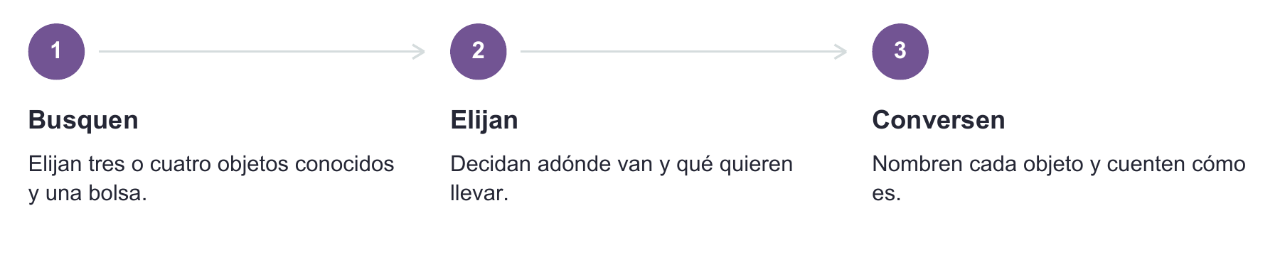
Usted: “Vamos al parque. ¿Qué guardamos en la bolsa?”
Su niño o niña: “Pelota.”
Usted: “Sí, la pelota roja. La llevamos para jugar.”
Use el color real del objeto. Si no es roja, cambie la descripción.
Si escucha “la pelota rojo”: puede responder “Sí, la pelota roja. Vamos a guardarla”. Sigan jugando. No hace falta pedir que lo repita muchas veces.
Si responde en inglés, señala o usa su comunicador: atienda lo que quiere decir y ofrezca una frase breve en español. No tiene que responder de una sola manera para participar.
Usen las palabras de su familia. Por ejemplo: la mochila pequeña o el bulto pequeño. Unos minutos durante una rutina pueden ser suficientes para esta práctica de casa. El equipo ajustará el plan; no hay una cantidad de repeticiones que funcione igual para todo el mundo.
Algo que dijo, señaló o nos contó
________________________________________________________________________________
________________________________________________________________________________
Algo que queremos compartir con el equipo
________________________________________________________________________________
Esta actividad acompaña el trabajo acordado con su terapeuta del habla y lenguaje. No sustituye las sesiones ni es una prueba. Si ya no lo están disfrutando, pueden dejarlo para otro momento.

07 EVIDENCE AND REFERENCES

What supports this kit
The clinical decisions should be individualized. The pictures, scripts, game rules, recording sheet, and home activity are original BEaR Lab resource content.

Directness of the evidence
Bedore et al. studied a broader Spanish language and literacy program with 15 first graders at risk and six typically developing comparison children. It included noun-adjective agreement and found improvement in elicited grammar and narrative length, but not overall grammaticality. Kornelis et al. studied three bilingual children with DLD and English verb targets, with variable Spanish transfer. Neither study establishes efficacy or dosage for this Spanish gender game. [3–4]
[1] American Speech-Language-Hearing Association. Multilingual Service Delivery in Audiology and Speech-Language Pathology. Practice Portal. https://www.asha.org/practice-portal/professional-issues/multilingual-service-delivery/ (Accessed September 26, 2026).
[2] American Speech-Language-Hearing Association. Collaborating With Interpreters, Transliterators, and Translators. Practice Portal. https://www.asha.org/practice-portal/professional-issues/collaborating-with-interpreters/ (Accessed September 26, 2026).
[3] Kornelis, M., Ebert, K. D., & Finestack, L. H. (2025). Exploring explicit intervention to target grammatical forms with Spanish–English bilingual children with developmental language disorder. Language, Speech, and Hearing Services in Schools, 56(4), 864–880. https://doi.org/10.1044/2025_LSHSS-24-00132
[4] Bedore, L. M., Peña, E. D., Fiestas, C., & Lugo-Neris, M. J. (2020). Language and literacy together: Supporting grammatical development in dual language learners with risk for language and learning difficulties. Language, Speech, and Hearing Services in Schools, 51(2), 282–297. https://doi.org/10.1044/2020_LSHSS-19-00055
[5] Castilla-Earls, A., Ronderos, J., & Fitton, L. (2023). Spanish bilingual morphosyntactic development in bilingual children with and without developmental language disorder: Articles, clitics, verbs, and the subjunctive mood. Journal of Speech, Language, and Hearing Research, 66(12), 4678–4698. https://doi.org/10.1044/2023_JSLHR-23-00091
[6] Real Academia Española & Asociación de Academias de la Lengua Española. Concordancia and género. Diccionario panhispánico de dudas, 2.ª ed. https://www.rae.es/dpd/concordancia ; https://www.rae.es/dpd/género . Mapa. Diccionario de la lengua española. https://dle.rae.es/mapa (Accessed September 26, 2026).
Practical editorial decisions: separate article and adjective outcomes; hide print during checks; use familiar family vocabulary; distinguish teaching from probing; avoid gender-coded colors; make participation possible through speech, gesture, or AAC; provide Spanish home practice. Human clinical usability testing and Spanish community review have not been completed for this original kit.

