14 DESK CHECKLIST

Working with interpreters
A quick practice manual for pediatric speech and language services
A quick practice manual for pediatric SLPs serving multilingual families. Start here before an interpreted assessment, treatment visit, or family meeting.
BEFORE  Agree on the task  ☐ Confirm the child’s languages and varieties; ask caregivers’ spoken and written language preferences and access needs.  ☐ Book a qualified interpreter who fits those needs. Arrange bilingual clinical consultation when required.  ☐ Brief the goal, materials, permitted prompts, and what must be preserved in the child’s response.  ☐ Agree on a pause signal, confidentiality, any recording permissions, and how to flag uncertainty. | DURING  Keep the exchange direct  ☐ Introduce roles. Speak to the family or child in short, natural segments; allow interpreting time.  ☐ Invite complete interpretation, including questions and side comments. Make clarifications visible to everyone.  ☐ Keep the child’s original response separate from its interpreted meaning and your clinical judgment.  ☐ Pause for dialect uncertainty, inaudible speech, added cues, or a changed task. Note what happened. | AFTER  Check and document  ☐ Ask the family to explain or show the agreed next step in their own way. Repair unclear explanations.  ☐ Debrief with the interpreter about uncertain wording, dialect, cues, and communication barriers.  ☐ Record languages, interpreter role, procedures, changes, and limits on scores or conclusions.  ☐ Give an accessible follow-up plan. Assign who will resolve open questions and when.

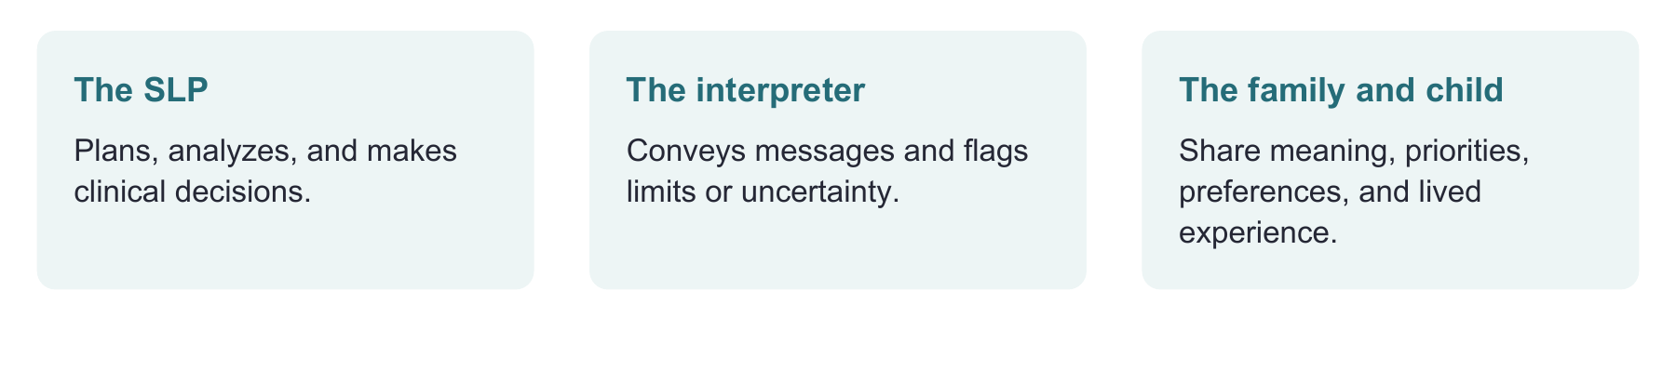

Use one agreed pause phrase
“Pause for clarification. Please tell us what was unclear before we continue.” For testing, follow authorized procedures. An unvalidated test translation cannot support a standard score; document changed prompts. [1–4]
Use this page as the desk checklist. Pages 2–4 give brief examples; page 5 records the visit. This is a practice aid, not interpreter training or a validated clinical protocol. Sources are listed on page 6.

PREPARE ONCE USE THROUGHOUT

Brief the interpreter before the visit
Use a brief huddle. The sample language below is original wording to adapt with your interpreter, not a script to read over the family’s conversation.
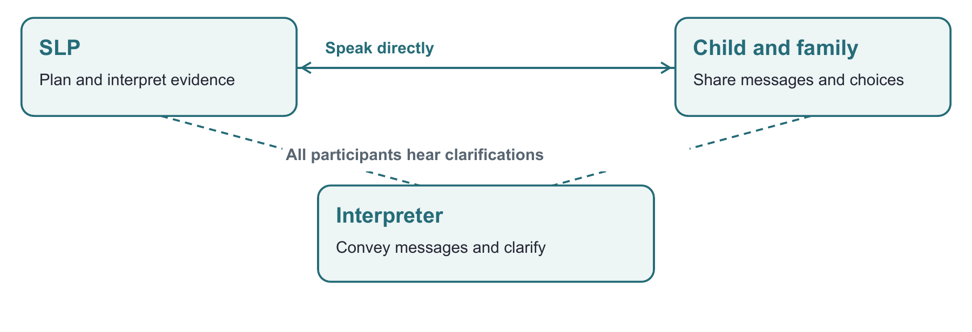
Agree on the work | A script you can use
Goal and role | “Today we are looking at how the child tells a story, not only whether the message makes sense. I make the clinical decisions; please flag any language or dialect uncertainty.”
Ordinary conversation | “Please interpret in first person when appropriate and convey the full message. I will speak directly to the family. Let us know when a phrase needs clarification.”
Assessment responses | “Please convey the meaning and flag unclear parts. For our agreed sample, also capture the child’s exact source-language words. Keep observed forms separate from inferred meaning. Do not guess at inaudible words.”
Permitted help | “For this task, these prompts are allowed: ____. Please pause before adding a hint, repeating, or rephrasing. We will record any change.”

Check the mode before the child begins
For remote visits, test sound and camera position with the actual task. Check that the child can hear, see, and use AAC or other supports. If audio masks speech details, defer sound-accuracy judgments and arrange a better sample. A clear interpretation of meaning does not verify the child’s speech sounds. [1,3,7]
A family member can contribute context and support. Do not default to a child, sibling, or an untrained relative as the interpreter. If there is a concern about privacy or community connections, offer a different qualified interpreter when feasible. [1,4]

TWO CLINICAL EXAMPLES

Preserve speech and language evidence
These fictional examples show what to preserve. They are not diagnostic rules or templates for assigning a disorder.
SPEECH CASE

The translation sounds clear
A child names pictures in Spanish. The interpreter gives clear English labels, but the SLP is unsure about the child’s final consonants. The interpreter notices a possible regional pronunciation pattern.
Pause: “Please separate which word you understood from how it was pronounced.” Keep the original sample with permission or precise notes within the team’s competence. Ask about community patterns; seek language-specific phonetic expertise when needed.
Clinical move: Intelligibility, intended word, and sound accuracy are different observations. An interpreter’s accent or imitation is not the child’s production. Judge patterns within the child’s languages and dialects, not against English rules. [1,3,7]
LANGUAGE CASE

A complete message can hide the form
A child says “La niña… el pelota rojo.” The interpreted message is “The girl has the red ball.” The interpreter supplied a plausible relation, but the original utterance did not state “has.”
Repair: “Please distinguish what the child actually said from what you inferred. We can record the intended meaning separately.” Retain the wording and uncertainty. A qualified bilingual clinician checks the broader language sample, familiarity, experience, and task demands.
Clinical move: One unusual phrase does not diagnose developmental language disorder (DLD). Do not count an adult’s fluent English interpretation as evidence of the child’s Spanish grammar. Keep inferred meaning separate from the recorded form. [1,2,4]

During treatment, record the planned teaching
Models, recasts and cues can be intentional treatment. Agree on them beforehand and log them. For a learning check, collect the independent response before the teaching model. Report which condition produced the response.

FAMILY PARTNERSHIP

Make family conversations usable
The English-speaking SLP uses these ideas through the interpreter, one question at a time. Reading Spanish sentences alone does not establish Spanish clinical proficiency.
Latino families differ in languages, dialects, identities, access needs, and experiences with services. Some use Indigenous languages or several languages. Ask about this family’s preferences and priorities. Do not infer them from a surname, nationality, accent, eye contact, or silence. [2,5]
Invite the family’s perspective | Natural Spanish wording to adapt
Language for each purpose | “¿En qué idioma prefiere conversar? ¿Y en qué idioma prefiere recibir la información por escrito?”
Family words and varieties | “¿Cómo le dicen a esto en casa? Si yo uso una palabra que no les resulta familiar, por favor díganmelo.”
Priorities and participants | “¿Qué le gustaría que [nombre] pudiera hacer con más facilidad al comunicarse? ¿A quién más le gustaría incluir?”
Clarify instead of guessing | “No me quedó claro. ¿Podría explicarlo de otra manera?”
Understanding the plan | “Quiero asegurarme de haberlo explicado bien. ¿Cómo harían esta actividad en casa? Puede contármelo o mostrármelo.”
Permission to question or disagree | “¿Qué parte de este plan no les funciona? Podemos buscar otra opción.”

Close with one shared action
Choose an activity the family wants and can fit into a routine. Demonstrate it, invite their version, and agree on follow-up. A teach-back checks the clarity of your explanation, not the family’s intelligence or compliance. Use it with all families, not only Spanish speakers. [6]
Offer spoken explanation, pictures, demonstration or written information according to preference and access needs. Use a qualified translator for written materials when needed; interpreting and written translation are distinct skills. Build on the child’s languages and the family’s priorities. [1,2]

AFTER THE VISIT

Close the visit and keep a useful record
Use an approved clinical record. Keep identifiers and recordings within your organization’s authorized systems.
Debrief question | Clinical action
Which meaning, form, or sound remains uncertain? | Keep the uncertainty in the record. Assign bilingual consultation or a new sample rather than forcing a score.
Did anyone repeat, translate, explain, cue, or change an item? | Name the change and its purpose. Follow the manual and available validity evidence when deciding whether a standardized score is interpretable.
Child says bulto for a backpack. Family confirms that word; the test lists mochila. What now? | Confirm the intended object. Check whether scoring rules allow that word. Record a regional term without automatically labeling it an error.

Languages and varieties used | Interpreter identifier and role | Modality
________________________________________________________________________________
________________________________________________________________________________
Task and permitted prompts | Changes actually made | Response conditions
________________________________________________________________________________
________________________________________________________________________________
Uncertainty and interpretation limits | Person responsible for resolving it
________________________________________________________________________________
________________________________________________________________________________
Agreed family action and preferred format | Follow-up date or plan
________________________________________________________________________________
________________________________________________________________________________
Example note: “Interview conducted in Spanish through a qualified interpreter; child tasks were sampled in Spanish and English with documented support. A response required clarification of a regional term. Meaning was confirmed; speech-form analysis remains pending bilingual review. No standardized score was derived from the altered probe.” [1–3]

EVIDENCE AND USE

Sources and boundaries
This manual applies professional guidance to brief pediatric clinical workflows. The checklists, scripts, diagrams and cases are original BEaR Lab practice aids. Their completion does not certify interpreter proficiency, establish test validity, or validate an intervention.
[1] ASHA. Collaborating with interpreters, transliterators, and translators. Practice Portal. Accessed September 27, 2026. https://www.asha.org/practice-portal/professional-issues/collaborating-with-interpreters/
[2] ASHA. Multilingual service delivery in audiology and speech-language pathology. Practice Portal. Accessed September 27, 2026. https://www.asha.org/practice-portal/professional-issues/multilingual-service-delivery/
[3] ASHA. Speech sound disorders: Articulation and phonology. Practice Portal. Accessed September 27, 2026. https://www.asha.org/practice-portal/clinical-topics/articulation-and-phonology/
[4] National Council on Interpreting in Health Care. (2005). National standards of practice for interpreters in health care. https://www.ncihc.org/assets/media/ncihc%20national%20standards%20of%20practice.pdf
[5] ASHA. Cultural responsiveness. Practice Portal. Accessed September 27, 2026. https://www.asha.org/practice-portal/professional-issues/cultural-responsiveness/
[6] Agency for Healthcare Research and Quality. (2023). Tool: Teach-back. https://www.ahrq.gov/teamstepps-program/curriculum/communication/tools/teachback.html
[7] McLeod, S., Verdon, S., & International Expert Panel on Multilingual Children’s Speech. (2017). Tutorial: Speech assessment for multilingual children who do not speak the same language(s) as the speech-language pathologist. AJSLP, 26(3), 691–708. https://doi.org/10.1044/2017_AJSLP-15-0161

When the team needs more expertise
An interpreter supports language access. A cultural or linguistic broker may clarify community usage. A bilingual SLP or other appropriately qualified specialist supplies clinical analysis within their competence. One person may hold more than one role; do not assume that language fluency supplies every role. [1–3]
Editorial approach: concrete actions and meaningful visual guides, no nationality-based communication rules, no assumption that a caregiver is the mother, and no inference of a disorder from one form or accent. The workflow is intended for clinical adaptation and has not undergone a timed usability study.
Quick use: print page 1 for the desk, share page 2 with the interpreter during preparation, and select the case or family script you need. A separate one-page checklist PDF accompanies this manual.

